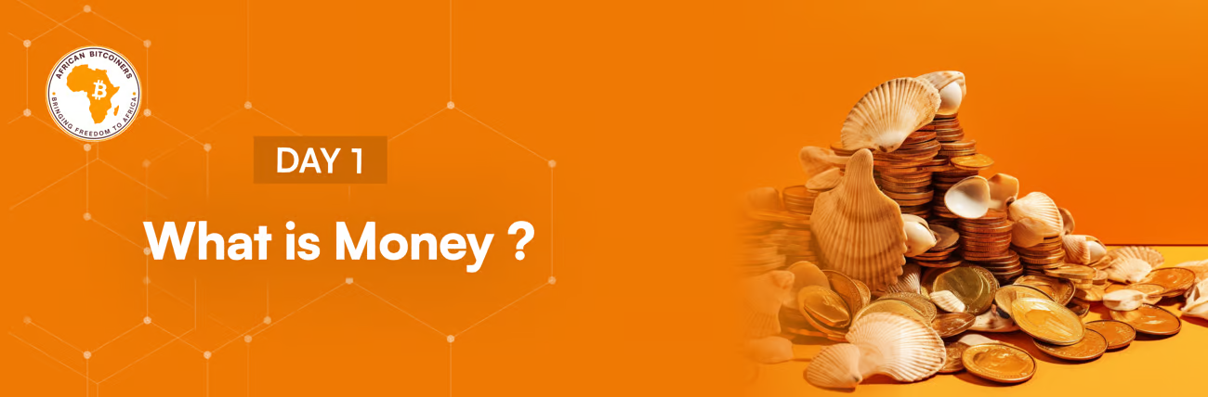

**Hello %FIRSTNAME%,**

**Did you know that no one has ever lost money saving monthly in Bitcoin over 5 years?** [**Check out our 5 year Bitcoin savings calculator to see for yourself**](https://bitcoiners.africa/5-year-bitcoin-savings-calculator/)**!**

Before we dive into the digital currency "Bitcoin", we must first understand the concept and the history of money itself.

**In ancient times, people traded by swapping goods.** Both sides needed to want what the other had, making trading tricky. Over time, people started collecting and assigning value to items like shells, salt, animal teeth, stones and even beads. These items functioned as “money” with the more scarce one being a better money. However, they struggled by not having one item universally valued by everyone.

Mesopotamia solved this problem by introducing the **“Shekel”** which provided a standard measure, but over time many societies evolved to the use of gold and silver coins. Gold was scarce and consistent which made it a good form of money, but it suffered a few weaknesses. It was heavy to move and easy to steal. This led to the next innovation as China started using paper money over 1000 years ago.

Many more nations soon started using paper money. At first it was backed by gold, but the temptation on the rulers to make more of it was too great and eventually that first currency was made to be worth nothing. This pattern of fiat currency debasement has repeated consistently for over 1000 years.

**As global trade grew, different currencies clashed.**

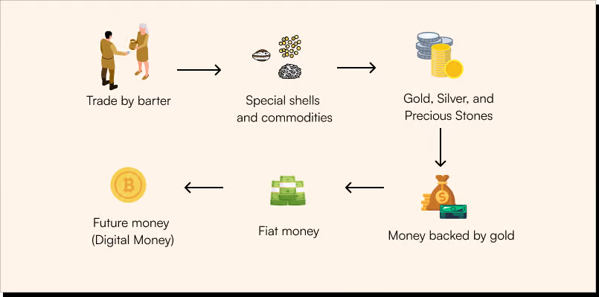

**History of Money**

Between 1815 and 1914, major countries, like the US, UK, and France, pegged their money to gold. This meant, for example, a Dollar represented a specific amount of gold and a Pound literally meant a pound of silver. This “hard money” led to one of the most prosperous and innovative eras in the history of mankind, but trusting governments with this system was risky.

During World War 1 many countries broke these promises of gold backed money and simply printed as much paper money as they needed to fund the war. However they didn't create anything more of value in their economies, just more money and this made everyone's money a little less valuable. This trick worked brilliantly! It meant governments no longer had to depend on the gold in their treasury, instead they could now rely on their people's accumulated wealth which could be expropriated through inflation to fund wars and their egos.

This shift marked a significant moment in the modern world where fiat money, backed only by the "trust" of government, rather than tangible assets, started to become the de facto money in society. And so began another 100+ years of fiat currency debasement up until today.

The difference between hard currency and fiat currency is simple. Hard currency, like gold, cannot be printed out of thin air. Fiat (which means “by decree”) currency can be printed out of thin air… just not by you. If you do it, it’s called counterfeiting.

Every fiat currency that has ever existed has been debased. Every single one. This debasement makes that currency less valuable over time (which you see as inflation) and this makes your wages and savings worth less and less over time and it will never end.

From this brief history, you can see how all governments manipulate currency to satisfy their ongoing quest for the growth of their own power. They actually can’t help themselves. The temptation to spend what you don’t have by printing money out of thin air is too great for any human to resist, and African governments are the best in the world at this. Can you buy less stuff with your money today compared to 5 years ago? It’s not even close. This government money printing is stealing from you. Your wages and savings are losing their value every day.

The truth is that money doesn’t have to be what your government says it is. Money is any “desirable” item or verifiable record generally accepted as payment for goods and services.

Imagine operating on a currency that no one can print more of. A money that gives you absolute control to transact as much as you want and an equal right to make decisions on everything concerning that currency. Bitcoin is that currency.

We don’t expect you to believe this truth 100% now, but just promise us you will dig into tomorrow’s content with this in mind, because we will be discussing the properties of money.

[Click here to take today's quiz](https://bitcoiners.africa/day-1-quiz/)

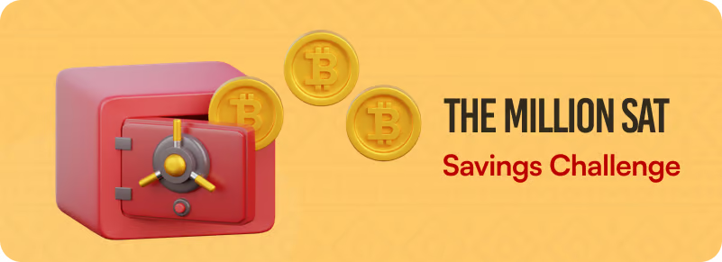

Money is central to every person’s ability to achieve their full potential and as long as we are concerned, Bitcoin is the only free and fair money.

The biggest determinant of your financial future are the choices you make about Bitcoin today.

We want you to be able to save a million sats, which will represent an investment in your future. If you can achieve this, you could be above average in global wealth in the near future.

To help you achieve this goal, we will be recommending places you can earn sats subsequently in this course. You can also signup for our Million Sat Challenge, a guide we have put together to help you learn about saving in Bitcoin!

[Sign Up for The Million Sats Savings Challenge](https://bitcoiners.africa/million-sat-challenge-confirmation/)

Your group of "decentralized" friends

**African Bitcoiners**

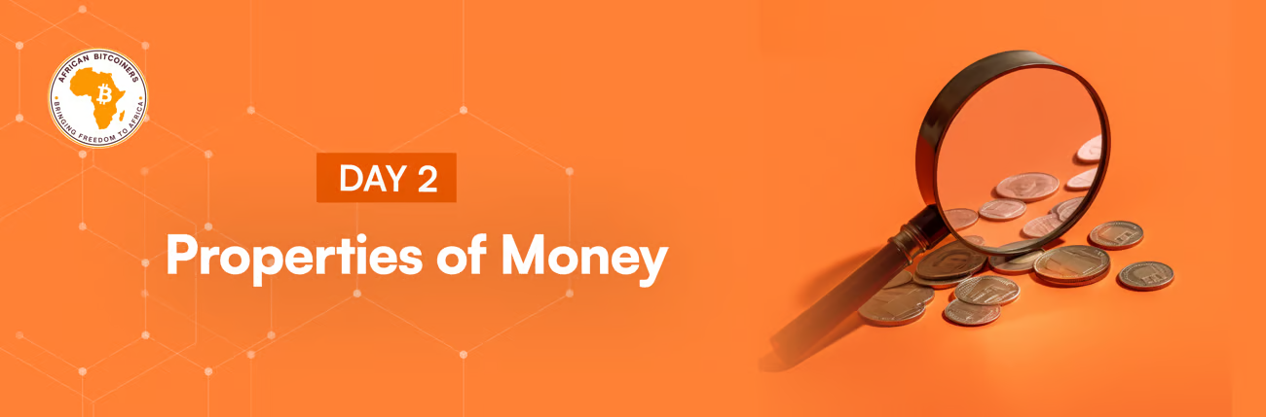

# Molo %FIRSTNAME%,

Did you know that you can keep Bitcoin in your head so no one can steal it?!🙈

We hope that you are enjoying this course as much as we enjoyed putting it together.

Yesterday, we learned that money is anything that is valuable and generally accepted by many. But what properties make anything valuable enough to be considered a store of value? Why can’t we pick up pebbles on the street and adopt those as our primary store of value? Or apples, everyone loves those. So why can't an apple be considered money?

Today, we will learn about the properties that make anything valuable enough to be considered money.

**The 10 properties**

* **Scarce:** Pebbles are common and in ample supply all over the world. If pebbles were money, anyone could get rich by running around and picking them up off the ground. This is effectively creating money out of nothing which just causes inflation and makes everyone poorer. So, pebbles wouldn’t work as a store of value. Anything considered money must not be common and it must have a limited supply.
* **Durable:** No matter how sweet apples or strawberries are, they can't be used as money because they are perishable. They will rot. A store of value must be long-lasting both in terms of value and material shelf life. For a good to be considered as a store of value, it also needs to preserve its value over time.
* **Divisible:** Money must have the capacity to be broken down into the smallest division or fractions.
* **Verifiable:** Before anything can be considered money, it must be verifiable as being authentic.
* **Fungible:** If a good or asset is interchangeable by the same measure of the good or asset, it is said to be fungible. For example one ounce of gold is interchangeable with another ounce of gold and 1 cedi is equal to another 1 cedi. On the other hand, two apples or two pebbles are never exactly the same.
* **Portable:** Money has to be portable enough to be carried around when needed.
* **Known History:** The longer a form of money has existed, the more people will agree or trust that it is valuable.
* **Desirable:** Yesterday, we told you that every nation found their way to gold as a store of value. Why gold? Well, because they all wanted gold! Before being used as money, gold was a prized possession because of its beauty and usefulness. So, a store of value should be desirable to everyone who wants to hold it.
* **Censorship Resistant.** To ensure it can maintain its long term value the use of a particular money should be resistant to suppression by any group or government.
* **Decentralised:** Good money is money that can’t be controlled by any central party. Bitcoin is the only currency that can boast of complete decentralization. It has rules, but no rulers.

From this list above, you can see that while our modern fiat money can tick 7 of these boxes, fiat currencies aren’t scarce, they aren’t censorship resistant and they aren’t decentralized.

Here is a table that gives a concise description of how gold, Bitcoin and Fiat currencies compare with these qualities of money.

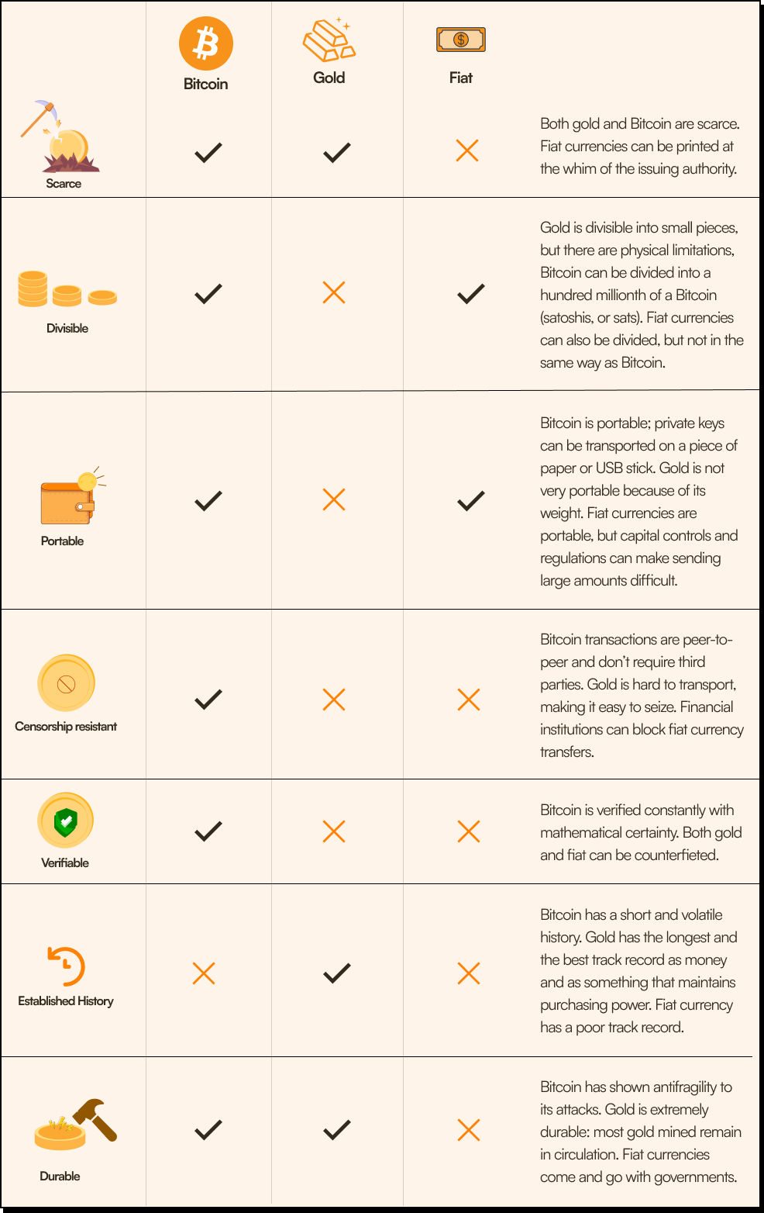

From the table above, you can also see why gold has been used as hard money for thousands of years. Apart from portability (it's very heavy!) it does well on most of these properties of money. However this lack of portability is a fatal flaw. With the growth of global trade, it wasn’t feasible to ship huge amounts of gold around which is why the world moved away from gold.

Bitcoin however can be sent anywhere in the world almost instantly and almost for free. In a modern digital world, this is a non-negotiable attribute. It ticks all the other boxes except a long history and that is something changing by the day.

As the saying goes “Fix the money fix the world”. Tomorrow we will dig more into these amazing attributes of Bitcoin that makes it the soundest money to ever exist that has the potential to fix our world.

**Extra reading**

For a more in-depth study into ways, Bitcoin has become more appealing compared to other money, read this article: [Bitcoin Obsoletes All Other Money](https://unchained.com/blog/bitcoin-obsoletes-all-other-money/)

[Click Here to Take Today's Quiz](https://bitcoiners.africa/day-2-quiz/)

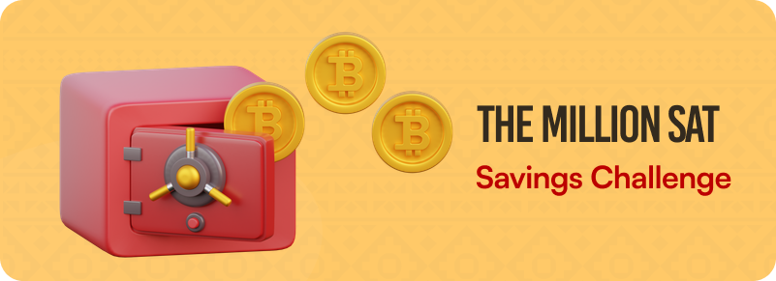

As we promised yesterday, we're excited to share some opportunities for earning sats! But let's start with the basics first. What exactly is a sat? 'Sat' stands for 'satoshis,' and it is the smallest unit of Bitcoin. One Bitcoin is divisible into 100 million satoshis, making it possible to hold and transact even tiny fractions of this digital currency.

You will also need a wallet where you can store the sats you stack. We will be teaching you about wallets sometime in this course, but for now please download [Wallet of Satoshi](https://www.walletofsatoshi.com/). Here's a video that shows [how to set it up and use it.](https://www.youtube.com/watch?v=Es4InK3lq5c)

Our first recommendation is [Microlancer](https://microlancer.io/), where you earn sats for completing micro tasks. [Click here](https://microlancer.io/) to check it out.

Stacking out for now

**African Bitcoiners**

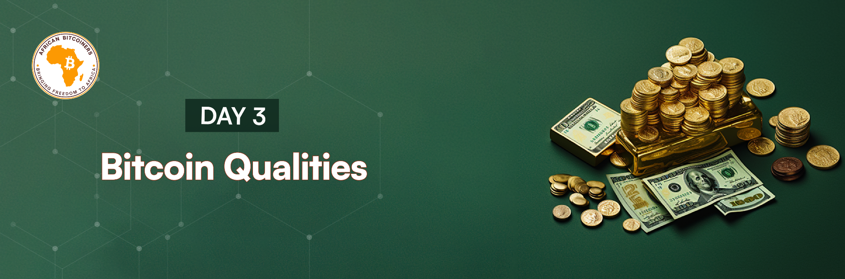

**Abuxeni %FIRSTNAME%,**

Yesterday, we talked about the properties of good money. And having ticked 9 out of 10 of those properties, Bitcoin comes out as the clear winner. The only one it doesn’t knock

out of the park is “known history”, but that’s ok; old isn’t always the best and Bitcoin gets a little bit more established and accepted every day.

Today we will be digging into the qualities that make Bitcoin irresistible. Don’t worry if you come across terms that you don’t really understand yet. It’s all part of the process, and it will be clearly explained as we walk through the course.

**Bitcoin’s 11 best qualities**

**1. Decentralization:** Bitcoin has no central control. There is no leader or group of people who control it in any way. It is impossible to turn off or change without convincing thousands of anonymous node operators and miners spread to all corners of the world. Bitcoin is totally and utterly unstoppable. This decentralization of Bitcoin provides many advantages such as resistance to seizure, taxation, and theft. It also makes it very hard to change which is why Bitcoin evolves so slowly. This is a good thing. You don’t want your money changing its properties without your control. Gold is valuable after thousands of years because it hasn’t changed.

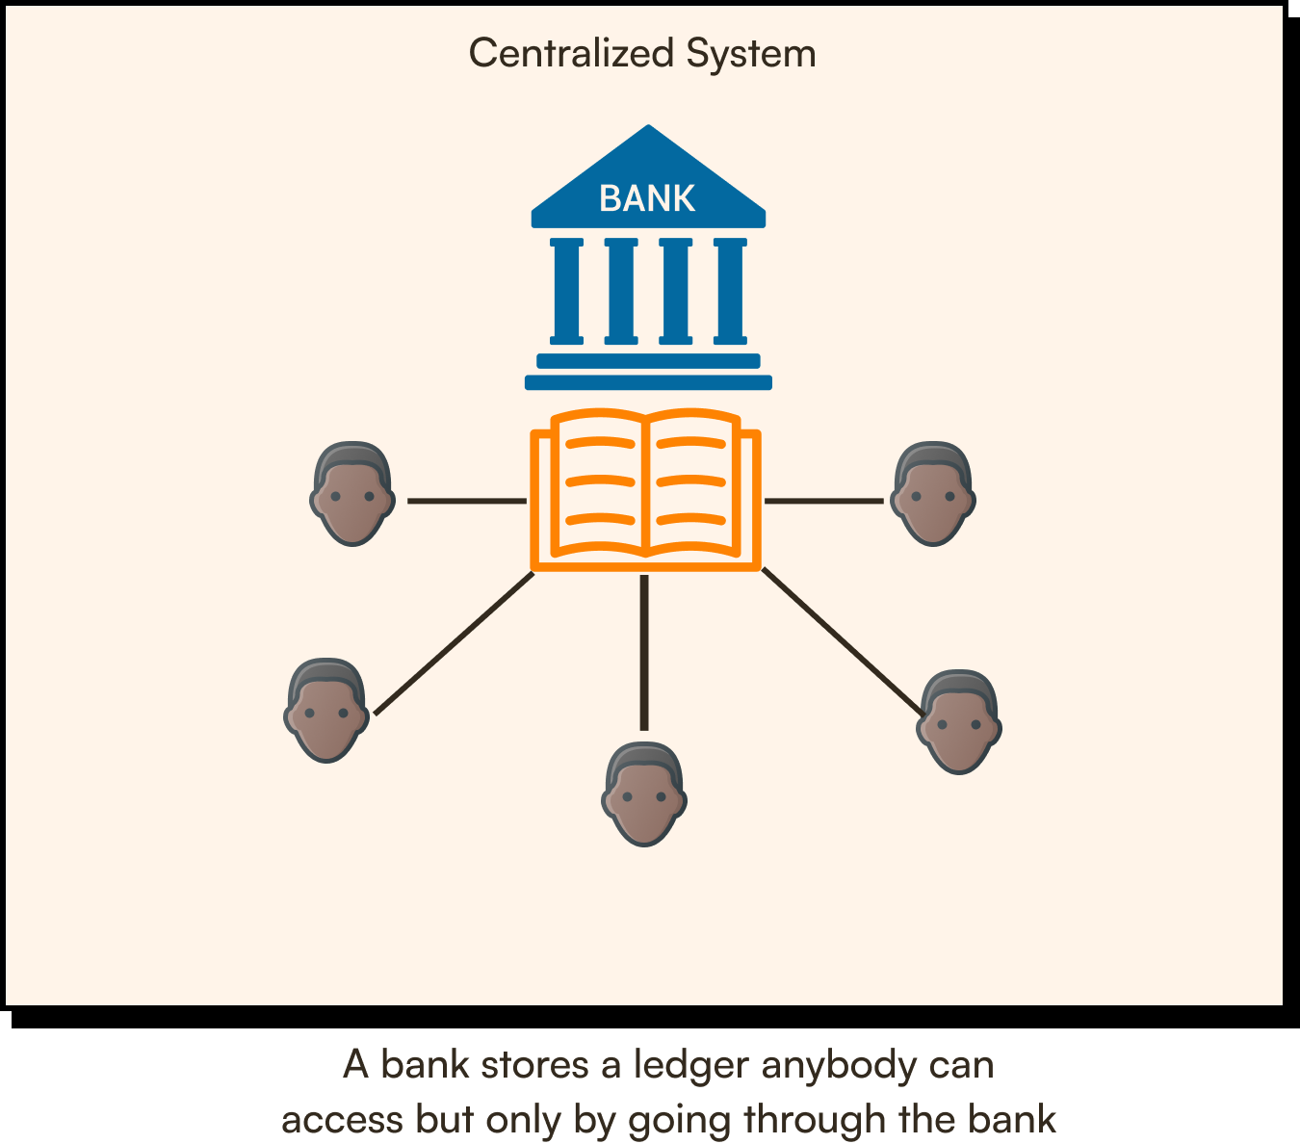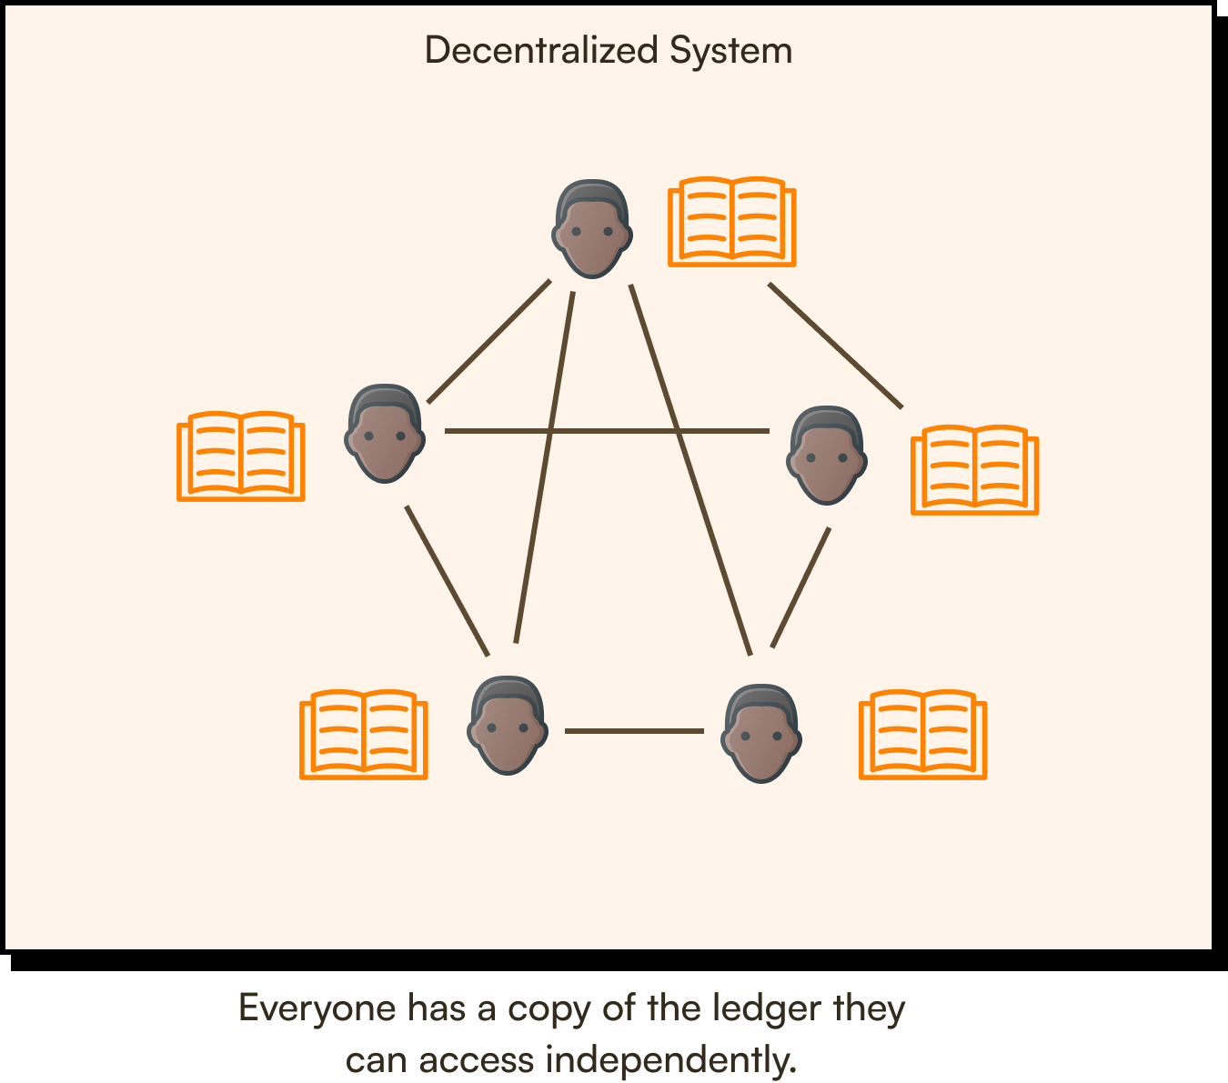

**2. Transparency:** No one can know how much Bitcoin you own. At the same time, your public address, the amount of Bitcoin in your public address, the number of transactions that the address has made, and the addresses that received and sent Bitcoin from and to you are visible to everyone on the blockchain. This is because while your public address and transaction history are visible on the blockchain, your identity is not tied to your public address or your transactions. Your public address is just a randomly generated string of alpha-numeric characters, not linked to any personal information, and you can have as many addresses as you want.

**So while others can see the amount of Bitcoin in a particular address, they don't know who owns that address unless you reveal your identity or tie it to a personal account or website. This is why Bitcoin is said to be pseudonymous rather than anonymous.**

**3. No one has even come close to performing a 51% attack on Bitcoin. A miner or validator would need more computing power than many countries to successfully conduct a 51% attack. The good news is that controlling 51% of the mining hardware and paying for 51% of the energy use of a large network like Bitcoin is extremely expensive and logically impractical. These inherent limitations are how control of the Bitcoin network stays decentralized.**

**4. Bitcoin cannot be destroyed:** Bitcoin is decentralized and there are over 100,000 interconnected nodes distributed all over the world. Even if 90% of these nodes are shut down or destroyed, those left will still be enough to keep the Bitcoin network alive. No one can turn Bitcoin off. Even if you turned off all the electricity and internet in the world, Bitcoin would pick up again like nothing ever happened as soon as the lights came back on.

**5. Bitcoin can move value across space and time:** Bitcoin's capacity to move value across space and time (an economic issue that has persisted for all of humanity's existence) is nothing short of revolutionary. By space, we mean sending it across the world, quickly, and by time, we mean over time, holding its value over years, decades and eventually centuries. Fiat is great at sending value of space (just not after business hours) and gold is great at holding value over time. Bitcoin can do both, better.

**6. Lightning speed transactions:** Unlike traditional payment methods the lightning network also allows you to send Bitcoin anywhere in the world almost instantly and free.

**7. Digital currency:** Bitcoin is not physically present in the form of notes or coins, unlike Fiat and gold, thus making it infinitely durable and instantly portable anywhere in the world.

**8. Value is determined by demand:** There is no fixed value or price. Bitcoin’s value and price entirely depend on its demand. The members of the Bitcoin ecosystem determine the cost and value of Bitcoin in the market. What we have seen is that the average demand for Bitcoin grows by a little bit each day. Because of Bitcoin’s fixed supply, this increase in growth, over time, leads to increase in value (with some wild swings along the way).

**9. Fixed supply:** Bitcoin is the only currency that can guarantee a fixed supply forever. Only 21 million Bitcoin will exist and everyone knows that and can verify it on the blockchain. This is a big advantage over fiat currency which is controlled by a small group of people who can change the supply at any time.

**10. Governed by everyone:** Bitcoin does not have a CEO! Everyone who runs a node - a computer system running the Bitcoin software - is part of the consensus that can decide if transactions are valid or not and can decide on whether they want to accept any changes to the Bitcoin core. This is unlike the fiat system where the central bank makes all monetary decisions and we all must just “go with their flow”. Bitcoin has rules, but it doesn’t have rulers.

**11. Transactions cannot be easily manipulated:** Transactions can only be manipulated if 51% of the Bitcoin mining power is controlled by the manipulator. A 51% attack occurs when a person or group of people take control of more than half of the computing power or validation authority of a cryptocurrency network. Having majority control of a cryptocurrency’s blockchain enables that group or person to create and manipulate incoming transactions (although it is exponentially harder to go back and change historical transactions). Some examples of 51% attacks on cryptocurrencies: Bitcoin Gold, 2018: Bitcoin Gold, a fork of Bitcoin, suffered an attack that led to an $18 million theft. Ethereum Classic, 2019: A fork of Ethereum, this blockchain experienced a 51% attack that led to roughly $1.1 million stolen.

Bitcoin is the future money! We envision a future where Bitcoin becomes the dominant global currency, surpassing traditional fiat currencies. This is called hyperbitcoinization and given Bitcoin's unique characteristics as better money, it is only a matter of when this happens, not if. As more individuals and institutions recognize and adopt Bitcoin's advantages, the belief in its potential to become a primary global currency gains traction.

We are positive that you are already very intrigued by Bitcoin’s advantages. If you’re still not convinced, that’s ok.

This course is all about taking a complex subject and breaking it up to empower you and your financial journey. Just keep an open mind and continue with the lessons.

[**Click here to take today's quiz**](https://bitcoiners.africa/day-3-quiz/)



Another place to earn Bitcoin is [Mash](https://mash.com/) which lets you convert your users into customers, fans & supporters by enabling them to pay for your creativity with an instant boost-donation. [Click here](https://mash.com/) to check it out.

We'll see you tomorrow

African Bitcoiners

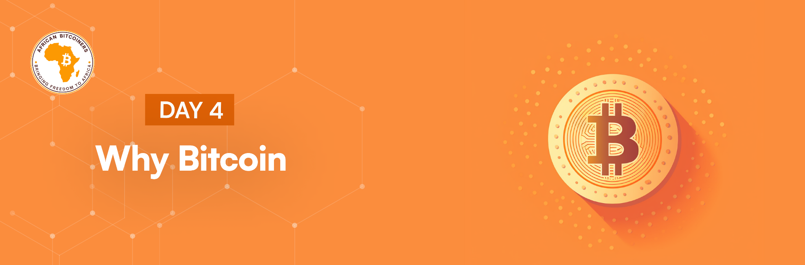

Hi %FIRSTNAME%,  
  
Here are some other questions to think about:

Why are we dedicating our time to creating Bitcoin awareness?

Why are a small but increasing number of people dumping fiat currencies and adopting Bitcoin as their primary store of value?

Why did El Salvador adopt Bitcoin as its legal tender?

What is driving people to learn about Bitcoin in the current high-inflation global economy?

Let’s look at this case study:

Tola is a Nigerian living in America. In 2019, he wanted to save some money so he sent $10 000 (the equivalent of 3.6 million naira) home in a fixed deposit savings account in Nigeria at the rate of one dollar to 360 naira, with a 5% annual interest yield.

Fast forward to January 2024. Tola needs $10 000 as a deposit on a home and decides to use the 3.6 million naira from the money he kept at the bank. With interest this money is now worth 4.14 million naira, but he gets a shock when he gets to the bank. His 4.14 million Naira are now worth $3 450 instead of $10 000!

His savings have depreciated by 61.8% and the spending power of this money has shrunk even more. In 2019, Tola could buy a plot of land for 3.5 million naira, but in 2023, the same land was being sold for 10 million naira. A whopping price increment (inflation) rate of 186% in 5 years, and to make matters worse, his international spending limit was reduced to $50 a month so, he can’t get the money back to the US!  
  
We want to highlight 3 important lessons from this story that will highlight the problems of fiat money and how Bitcoin solves each problem.

1. **Inflation:** Inflation is a general increase in the prices of goods and services in an economy. When governments print money from nothing, they don’t actually produce anything of value. This monetary debasement just creates a situation where an economy has more money in circulation buying the same amount of goods and services. This simply pushes prices up which is a hidden tax on all of us as our money can now buy less. The dollar has already lost 98% of its value in the last 100 years, but African currencies have fared even worse with most of them being inflated to nothing over much less time.  
     
   Bitcoin allows people to save in hard money which does not suffer from inflation. Yes the price may go up and down, but it will always increase in value against fiat currencies which are constantly being debased through government printing. No one has ever lost money saving in Bitcoin for 5 years or more. (see for yourself [here](https://bitcoiners.africa/5-year-bitcoin-savings-calculator/))
2. **Currency devaluation:** This is the devaluation in the purchasing power of a country’s currency against other currencies. This is a constant reality for the majority of African currencies largely because of government mismanagement and corruption. When one currency inflates more than the other, the exchange rate will reflect that. This effect is also supercharged in Africa because we spend so many dollars on imports and sell all our natural resources for dollars which further hurts our exchange rate. There will only ever be 21 million Bitcoin. It can never be inflated which is why its purchasing power grows against other currencies instead of falling.
3. **Loss of control:** Governments always want to be in control of money because it gives them power. While western government can boast about the power it gives them, Africa can't do the same. Only 9 African countries print their currency in their country. In a continent of 54 countries, less than 10 have the capacity to print their own currencies or mint their own coins. The CFA fiat holders have had their money printed at Chamalières by the Bank of France since its creation in 1945. The Ghana Cedi is being printed by De La Rue, a security printing firm based in the United Kingdom. And we pay dollars to buy our own Fiat currency and have no control over how much of it is being printed. Then our Governments set rules to protect their "failed system", a system they have no real control over and often these rules are not friendly to their citizens. From KYC privacy intrusions to international spending limits, these arbitrary rules are made with no regard to their adverse effects.

Back to our story, Tola ended up losing out on his international investment because even if he could get the $10 000, he was only permitted to send $50 every month. Bitcoin solves this problem. It is not censorable and controlled by no one, so you can send any amount anywhere at any time.

These are just a few of the reasons why we really believe in Bitcoin!

We look forward to seeing you tomorrow when we go a bit deeper under the hood of this incredible discovery.

[**Click here to take today's quiz**](https://bitcoiners.africa/day-4-quiz/)



**Ready to earn some sats today?**

**If you are a content creator** [**Zion**](https://www.zion.fyi/) **is a great place to earn sats for your contents.** [**Click here**](https://www.zion.fyi/) **to learn more.**

**Chat tomorrow**

**African Bitcoiners**

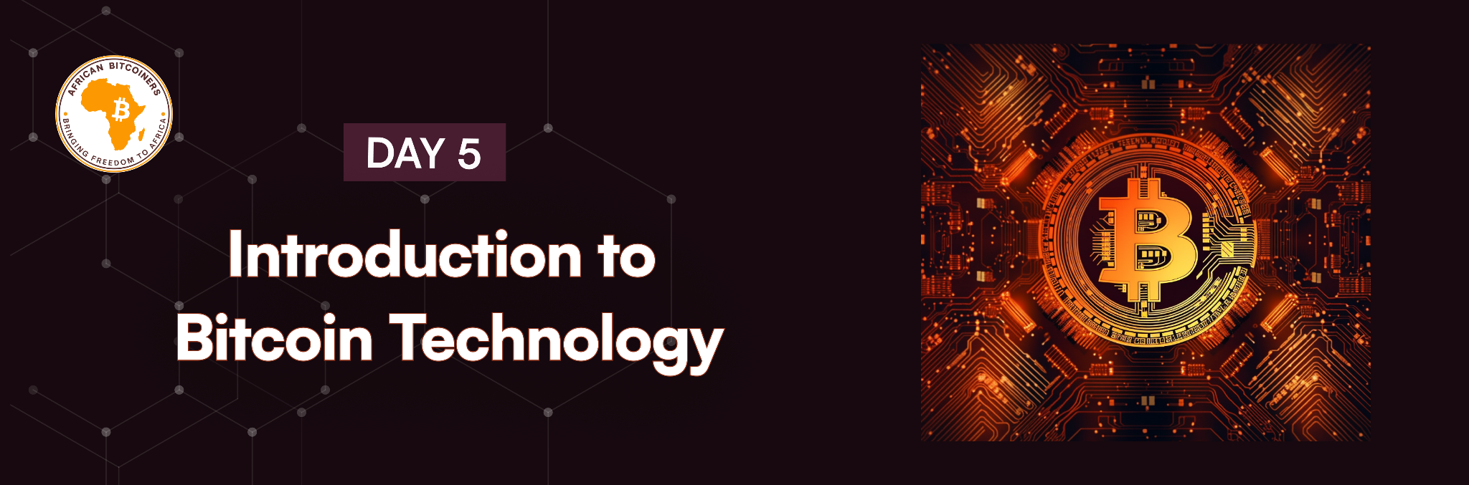

**Yema wo akwaaba %FIRSTNAME%!**

**Day 5, you are absolutely killing it!**

**Here are 6 things you should never forget about Bitcoin:**

1. **The Bitcoin price is volatile and that’s OK:** The price can rise or fall in unpredictable ways over a short period of time due to its young economy, new nature, and sometimes non-liquid markets. That’s why Bitcoin for your short-term savings is not recommended at this point. However Bitcoin is volatile in an upward direction. No one has ever lost purchasing power by saving Bitcoin for 5 years or more (you can test this theory [here](https://bitcoiners.africa/5-year-bitcoin-savings-calculator/)), what other currency can say that?
2. **Bitcoin payments are irreversible:** Once you have sent out a payment and received a confirmation, your Bitcoin is gone forever and can't be reversed back to you. So, you need to be certain of the address to which you are sending your Bitcoin.
3. **Bitcoin is not anonymous:** Bitcoin records all transactions in a public ledger, so everyone on the blockchain can see transactions made by your address. The secret to privacy is to never associate your name with that address. So, it is important to avoid wallets that request KYC (Know Your Customer) information from you.
4. **Bitcoin is not yet an official currency in most parts of the world.** Many vendors accept it, including big stores like PicknPay in South Africa. Occasionally, vendors may not display explicit signs indicating Bitcoin acceptance, but they still accommodate such transactions, so you may have to ask. Only El Salvador has so far made it legal tender but, many countries are also friendly to it.
5. **Unconfirmed transactions are not secure.** A transaction that has been sent but not yet confirmed into a block can still be changed and the funds sent to another address. Always wait for at least one confirmation, ideally 6 if you want to be beyond certain.
6. **Not your keys, not your Bitcoin:** If you do not have control over your private keys, then you do not actually 'own' your Bitcoin. When you possess the private keys to your Bitcoin wallet, you have full control over your funds. You can make transactions at will, secure your assets as you see fit, and essentially "own" your Bitcoin in the truest sense. If you entrust your private keys to a third party, like a cryptocurrency exchange or wallet service, you are, in a way, relying on them to act in your best interest.

**This is probably the most important thing to remember.**

Come back to these 6 points often – until you can say them in your sleep. Now, let’s dig in.

**What exactly is Bitcoin?😲**

Bitcoin is a decentralized digital currency that can be transferred on the peer-to-peer Bitcoin network. Transactions are packaged into blocks roughly every 10 minutes and these are verified by the nodes in the network. Valid blocks are recorded in public and each one is added to a distributed ledger called a blockchain (a chain of blocks). You may notice that “Bitcoin” and “bitcoin” are used interchangeably throughout the course. Strictly speaking, “Bitcoin” is the network and “bitcoin” is the currency, but we often don’t get that right, so just use Bitcoin 😃.

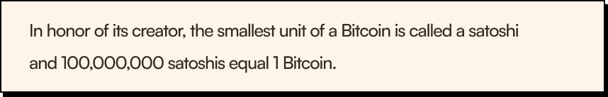

Bitcoin was created by **Satoshi Nakamoto,** a person or a group of people who, to this day, have not been identified. A year after creating Bitcoin, Satoshi Nakamoto disappeared leaving behind an estimated 1 million Bitcoin. Clearly Satoshi Nakamoto does not care about wealth or fame as to this day their Bitcoin remains untouched.  
  
Tomorrow, we are going to be studying the history of digital money and how Bitcoin started.

You know the drill, read over the lesson again to make sure you understand it then take the quiz below👇

[**Click here to take today's quiz**](https://bitcoiners.africa/day-5-quiz/)



If you plan to run projects that contribute to Bitcoin growth then try [Geys](https://geyser.fund/)er. Geyser is a crowd funding site where you can raise money for your Bitcoin project from the Bitcoin community. [Click here](https://geyser.fund/) to check it out.

Your group of "decentralised" friends

**African Bitcoiners**

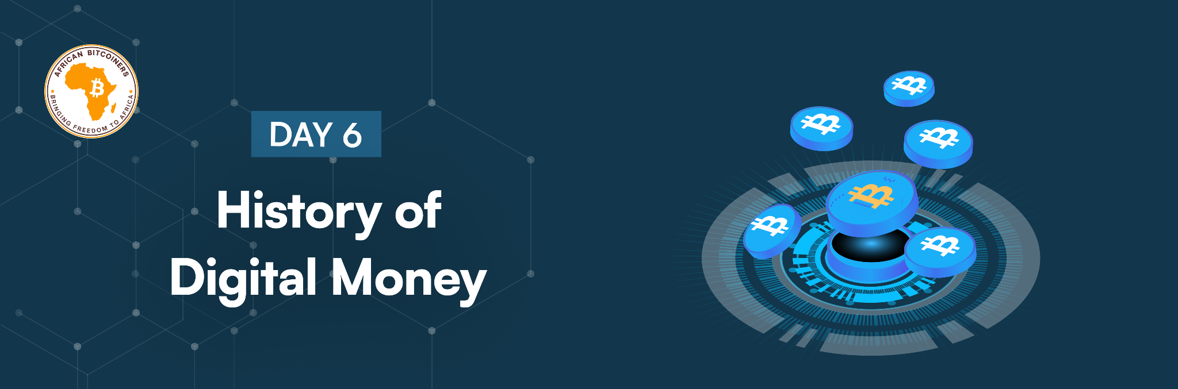

**Hi %FIRSTNAME%,**

Today we are looking at the history of digital money and how various digital monies prior to Bitcoin paved the way. Because we are dealing with a relatively new currency, you can even follow some of the people we mention like [Adam Back](https://twitter.com/adam3us), [David Chaum](https://twitter.com/chaumdotcom), and [Nicholas Szabo](https://twitter.com/NickSzabo4) on Twitter. A modern-day history.😃

Cryptography is the technology that gave birth to all digital currencies ever created. A cryptocurrency is a digital currency that uses cryptography for security, some of the earliest cryptocurrencies ever created include:

* David Chaum’s [DigiCash](https://en.wikipedia.org/wiki/DigiCash)
* Adam Back’s [Hashcash](https://en.wikipedia.org/wiki/Hashcash)
* Wei Dai’s [B-money](https://www.investopedia.com/terms/b/bmoney.asp)
* Szabo’s [Bit Gold](https://www.investopedia.com/terms/b/bit-gold.asp#:~:text=What%20Is%20Bit%20Gold%3F,to%20Satoshi%20Nakamoto's%20bitcoin%20protocol.)
* Satoshi Nakamoto’s [Bitcoin](https://bitcoin.org/bitcoin.pdf) (our favorite, obviously)

**The 3 basic questions anyone accepting digital money should consider are:**

1. Can I trust this currency to be valuable?
2. Can I trust that I have complete access to my funds with no third party involved?
3. Can I trust that no one else can steal these funds?

Before Bitcoin, many digital money prototypes failed to pass the test when it came to these 3 questions. Satoshi Nakamoto answered these questions in the Bitcoin [White Paper](https://bitcoiners.africa/bitcoin-whitepaper/), a document outlining the design of the Bitcoin protocol published in October 2008. Nakamoto combined prior inventions such as B-money and Hashcash to create a completely decentralized electronic cash system that does not rely on a central authority for currency issuance or settlement and validation of transactions. Bitcoin is both a new currency and a new kind of payment system. It’s unique in the way it works using a peer-to-peer network to prevent double-spending and money creation.

Satoshi mined the first Bitcoin block (Genesis Block) on Jan. 3, 2009. That was three months after he or she published the Bitcoin white paper in an online cryptography forum. People now call Jan. 3 “Genesis Block Day. The message encoded in the Bitcoin genesis block reads:

**"The Times 03/Jan/2009: "Chancellor on brink of second bailout for banks"**

This text is widely interpreted as a reference to a headline from "The Times" newspaper on January 3rd, 2009, reflecting the financial instability and the context of Bitcoin's creation as a decentralized alternative to traditional financial systems.

On January 12, 2009, Satoshi Nakamoto sent 10 Bitcoin to Hal Finney, a prominent figure in cryptography and one of the earliest contributors to Bitcoin's development marking the first ever Bitcoin transaction.

Bitcoin's first big moment came with the Silk Road, the first underground marketplace on the dark web to use Bitcoin as its primary currency. It was established by Ross Ulbricht and operated from 2011 until its closure by law enforcement in 2013. Silk Road facilitated various transactions, both legal and illegal, and gained significant attention for its role in the sale of illicit goods and services.

Bitcoin has even had its fair share of fraudsters. Craig Wright an Australian computer scientist and businessman publicly claimed to be Satoshi Nakamoto, the pseudonymous creator of Bitcoin but faced skepticism and has been refuted by many in the Bitcoin community.

**Bitcoin consists of:**

1. **A decentralized peer-to-peer network (the Bitcoin protocol):** is a collection of nodes and miners who together order and validate transactions while securing the blockchain and preventing any sort of double spending.
2. **A public transaction ledger (the blockchain**): is a chain of blocks each of which contains a batch of irreversible records, called transactions.
3. **A protocol or set of rules (consensus rules):** these rules govern the validity of transactions and block creation. It can only be changed if the whole network agrees.
4. **A mechanism (Proof-of-Work algorithm**): for reaching a globally decentralized consensus on the validity of the blockchain**.**

**Extra learning:**

The history of digital money is very interesting. [Read more about it here](https://bitcoinmagazine.com/culture/bitcoin-adam-back-and-digital-cash)

[**Click here to take today's quiz**](https://bitcoiners.africa/day-6-quiz/)



You’ve learned a lot over the last 6 days! Check out the Bitcoin Magazine app that lets you earn Bitcoin for reading the latest Bitcoin news articles, watching live streams, participating in giveaways, surveys, and more. It's like earning cash-back rewards, except with Bitcoin instead of dollars! Download the Bitcoin Magazine app [here](https://www.bitcoinmagazine.app/).

Yours in earning and learning sats,

**African Bitcoiners**

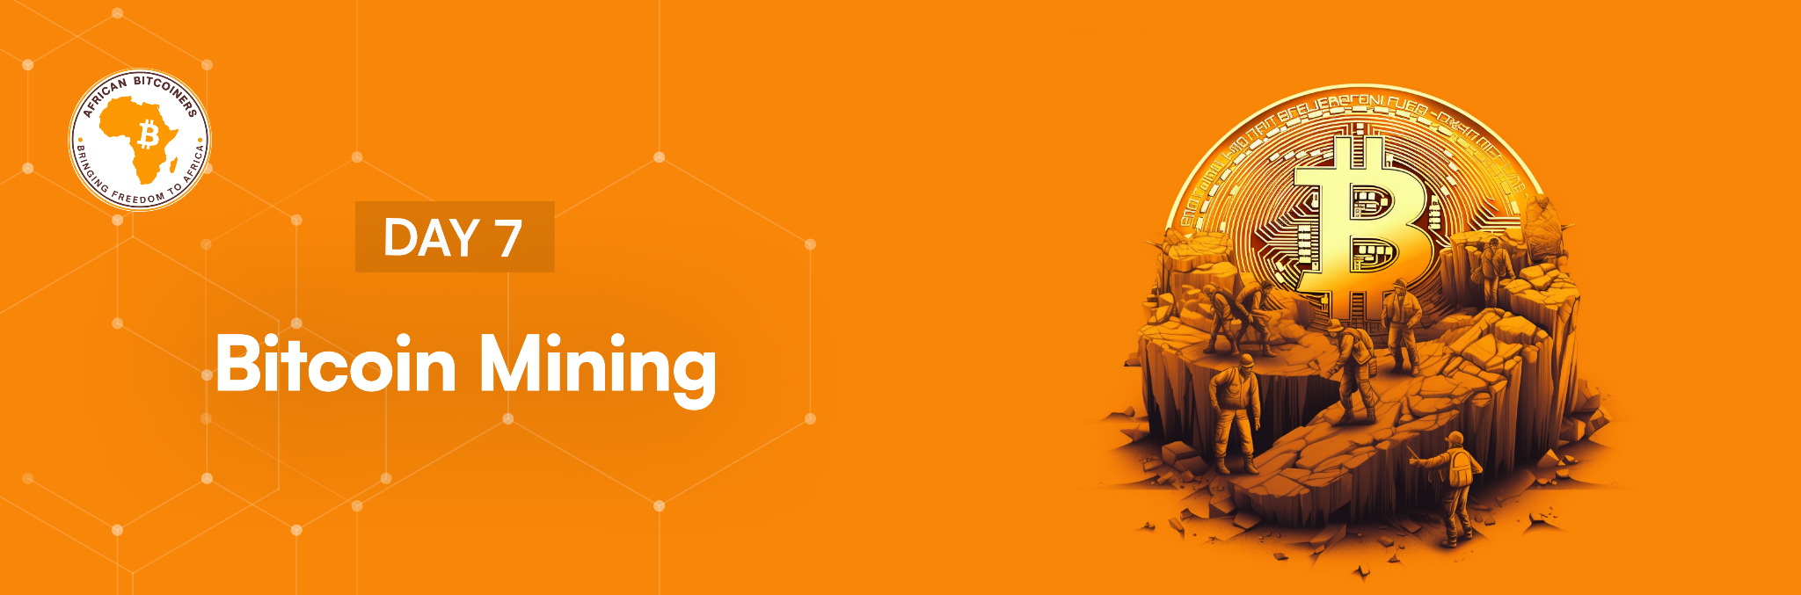

**Mhoro %FIRSTNAME%**

Bitcoin is the future, and we love that you are intentional about your future!

There will only ever be 21 million Bitcoin and as of 1 January, 2024, 19,596,606.25 of that 21 million Bitcoin have been issued. How does more Bitcoin get created?

Today we are digging into Bitcoin mining, the mind-blowing innovation through which more Bitcoin are created.

For a beginner, mining is the process by which a new Bitcoin is issued into the Bitcoin network. This involves the ordering of valid transactions in the Bitcoin network and creating a block of these transactions for verification by the Bitcoin nodes. Every time a block is confirmed by the Bitcoin network, miners get new Bitcoin and the transaction fees from each transaction in the block as a reward.

Transactions sit in a queue called a mempool and are ordered based on who pays the highest fee. Miners compete to build a block of transactions, and once they win, they create the block which is added to the chain. Each block can hold about 2000 transactions, so if you pay enough in a fee, your transaction will be included in the block.

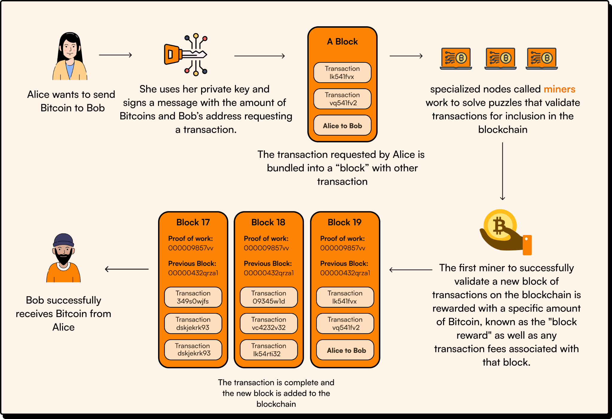

**Understanding the Basics of Mining:**

* **Mempool:** The word mempool is an abbreviation for Memory pool. Think of a Mempool as a waiting area for transactions in the Bitcoin network. Each node has its own mempool of pending transactions. These transactions are ordered based on the fees paid, with higher fees receiving higher priority. A large Mempool size indicates more network traffic, which will result in a longer average confirmation time and higher priority fees. [Click here](https://mempool.space/) to view the Bitcoin mempool.
* **The Bitcoin blockchain is a decentralized and distributed ledger that securely records all Bitcoin transactions ever made.** It serves as a digital database that stores a chronological chain of blocks, each containing a list of validated transactions. This blockchain ensures the transparency, immutability, and integrity of the Bitcoin network without relying on a central authority or trusted third party. It allows participants in the network to verify and track the history of transactions, preventing double-spending and providing a foundation for a trustless and decentralized financial system.
* **A Block** is a unit of data that contains a collection of transactions. It serves as a fundamental building block of the blockchain. A Bitcoin block header is a critical part of each block within the blockchain. It's a concise summary or metadata about the block itself. The block header contains several essential components:

1. **Block Version Number:** This number indicates the software version used to create the block
2. **Previous Block Hash:** A hash is a fixed-size alphanumeric string generated by a mathematical function called a cryptographic hash function. This function takes input data, such as a block of transactions, and transforms it into a unique and seemingly random string of characters. Every block consist of the hash of the previous block's header, thereby forming a chain of blocks.
3. **Merkle Root:** The root hash of all transactions in a block, used to verify the integrity of the data and prevent double-spending.
4. **Timestamp:** The timestamp records when the block was created.
5. **Difficulty Target:** A value that represents the complexity of the mathematical problem miners need to solve to add the block to the blockchain.
6. **Nonce:** A 32-bit variable that miners change when attempting to solve the cryptographic puzzle. Altering the nonce affects the block's hash and helps find a valid block.

This header, combined with the block's transactions and a nonce that miners manipulate to find a valid hash, constitutes the entire block. Miners work to find a nonce that, when combined with the block's data, results in a hash that meets the network's difficulty target, thus "mining" a new block. This block is then added to the existing blockchain, forming a continuous chain of blocks. A very clever part of Bitcoin’s design is that the difficulty of the mathematical puzzle adjusts no matter how much mining power there is in the network. This difficulty adjustment ensures that a new block is created every 10 minutes on average.

Consequently, users generating Bitcoin transactions are in a fixed bidding war where the level of transaction fees changes based on the number and urgency of transactions needing to be processed.

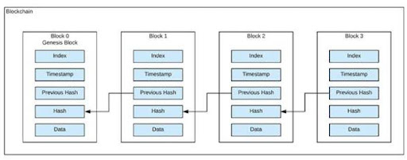

This diagram shows a chain of connected blocks.

* **Mining Hardware:** Bitcoin mining activities are carried out by ASIC hardware devices. ASIC stands for Application-Specific Integrated Circuit. These are specialized hardware devices meticulously designed for the sole purpose of mining Bitcoin. These ASICs are engineered with an intense focus on computational power and energy efficiency, tailored precisely for the specific algorithm used in Bitcoin mining—SHA-256.  
    
  Apart from individual miners, Bitcoin mining also occurs within mining pools. These pools are collaborative groups of miners who combine their computational resources to increase their chances of successfully mining a block and sharing the rewards among the pool members. The first mining pool, **Slush Pool**, was established in late 2010 by Marek Palatinus, also known as Slush. It introduced a new approach, allowing multiple miners to work together and share rewards based on their contributed hashing power.
* **Transaction Fees:** to have your Bitcoin payment transaction verified. When a user generates a transaction, they have to include a transaction fee to be paid to miners to incentivise miners to include their transactions in the next block. Transaction size and network congestion influence the priority and amount of transaction fees in the Bitcoin network. When a miner successfully finds a block, they get a block reward plus the transaction fees from all transactions in the block. As each block is limited to effectively 1MB, miners will generally try to get transactions with higher fees into the block first.Consequently, users generating Bitcoin transactions are in a fixed bidding war where the transaction fees need change based on the number and urgency of transactions needing to be processed. An unprocessed transaction sits in a Mempool. To avoid waiting too long in a Mempool for transaction validation, users making quick transactions may opt to pay higher fees than those who aren’t in a rush.

**Replace-by-Fee(RBF)** feature in some wallets allows users to replace unconfirmed transactions with new ones featuring higher fees**.**

**Child-Pays-for-Parent (CPFP) Child-Pays-for-Parent (CPFP)** is also a technique that incentivizes miners to confirm both a new transaction and its unconfirmed "parent" transaction. These techniques are both beneficial when an initial transaction is stuck in the mempool due to a low fee.After a miner receives the block reward, they have to wait 100 blocks before they can send it to another address. This period of waiting for the block reward to be spendable is called **The coinbase maturity period.**  
See the image below for better understanding of transaction fee.👇

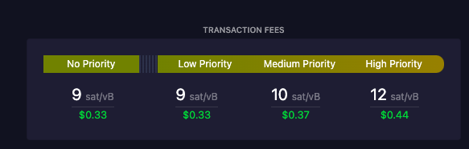

This image shows various transaction fees on the Bitcoin network (at the time of screenshot).

* **Proof of Work:** Proof of Work (PoW) is a consensus mechanism used to validate and confirm transactions and secure the network against malicious activities. In PoW, miners compete to solve a mathematical puzzle requiring significant computational power and energy expenditure.

**Here's how PoW works:**

* **Puzzle Solving:** Miners gather transactions into a block and aim to find a solution to a cryptographic puzzle. The puzzle requires miners to repeatedly guess to find the hash of a block. Interestingly, because the odds of guessing the correct hash remain the same no matter how many guesses have been made, a new block is ALWAYS expected to be 10 minutes away whether the last one was 20 minutes or 20 seconds ago. Just like the odds of flipping heads on a coin are always 1:2 no matter how many tails you’ve just flipped.
* **Difficulty Adjustment**: This is one of Satoshi’s most clever inventions. The Bitcoin network adjusts the difficulty of the puzzle every 2016 blocks (roughly every two weeks). If blocks are created too quickly, indicating high computing power, the difficulty increases to slow down block creation. Conversely, if blocks are created too slowly, indicatinglower computing power, the difficulty decreases to speed up block creation. By continuously adjusting the difficulty, the network strives to strike a balance and uphold the desired block creation time of 10 minutes, this regular recalibration, known as the 'difficulty epoch,' safeguards the network’s stability and maintains the predictability of block generation within the Bitcoin blockchain.

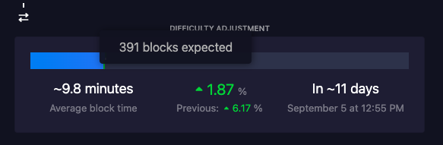

This image shows the difficulty adjustment of Bitcoin (at the time of screenshot). The next adjustment is expected in 391 blocks time (out of a total of 2016 blocks in a difficulty epoch). Currently, blocks are being produced at an average time of 9.8 minutes which is a little too fast so at the next difficulty adjustment in about 11 days, difficulty will be adjusted upward by 1.87 seconds making blocks harder to produce and bringing block time average back up to 10 minutes.

* **Solution Verification:** Once a miner finds a solution, they broadcast it to the network. Other miners quickly verify the solution by confirming that the hash meets the required conditions. When two miners solve a block at the same time, a temporary split is created in the blockchain, known as a fork. This occurs because both miners might have different versions of the next block due to the decentralized nature of mining. The network resolves this by accepting the longest chain, which signifies the most computational work performed.
* **Block Addition:** When a miner's block solution is verified and accepted by the nodes, it is added to the blockchain, linking it to the previous block. Miners receive a reward in the form of newly minted Bitcoins and all the transaction fees from the included transactions.
* **Bitcoin Block Rewards and Bitcoin Halving:** What is a Bitcoin Block reward? As we mentioned earlier at the beginning of today’s lesson, a Bitcoin Block reward is an amount of bitcoin given to the miner which solves the sophisticated mathematical puzzle and thus adds a block of transactions to the block chain. This reward is a specific amount of new Bitcoin, in addition with all the transaction fees associated with every single transaction contained in that block. As at the time this course was delivered to your email, a block reward is pegged at 6.25 Bitcoins. This means that a miner gets 6.25BTC plus all the transaction fees of all the transactions in that block.

Now that you know what a Block reward means exactly, you’d obviously be asking, what is **“Bitcoin Halving**” and what does it have to do with “Block Rewards”?

Bitcoin halving is an activity that happens after every 210,000 blocks. When calculated at an average 10mins per block time, you’ll find out that this activity happens approximately every 4 years. So what is this activity exactly? Bitcoin halving is a process that divides the block reward given to Miners in half. This halving of the block reward was hardcoded into the bitcoin protocol (you’ll learn about bitcoin protocol later in this course) so that the network would exponentially reduce the amount of bitcoin coming into circulation over time, thereby making bitcoin more scarce as years go by.

A quick look at the history of bitcoin halving shows that the first block reward after Bitcoin was released was 50BTC. Four years later in 2012, it was slashed to 25BTC, then 12.5BTC and currently 6.25BTC. By April 2024, another Bitcoin halving would occur, hence reducing block rewards to 3.125BTC. The last Bitcoin is expected to be mined by 2140.

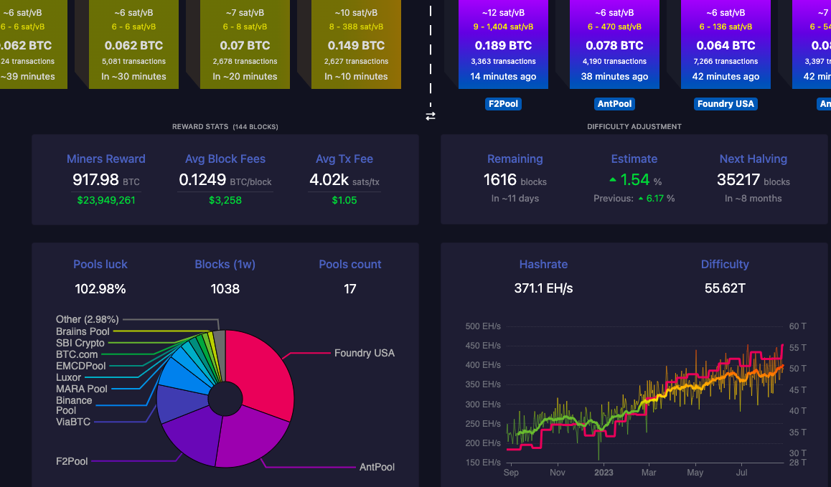

This image shows the mined and unmined transaction blocks, miners reward, average block fees, average transaction fees, etc.

Today, you have learnt that mining is the process by which new Bitcoin is generated by solving mathematical problems that confirm transactions waiting in a Mempool. We know that today was quite complex, perhaps read the lesson a few times over. This will all start getting clearer soon.

And we hope that you are earning as much as you can from the Bitcoin Magazine App we shared yesterday😎.

[**Click here to take today's quiz**](https://bitcoiners.africa/day-7-quiz/)



[Lncal](https://lncal.com/) helps you get booked and paid in Bitcoin for your services. All you have to do is share the link to your public calendar so that people can schedule you and pay you in Bitcoin. [Click here](https://lncal.com/) to check it out.

Till tomorrow

**African Bitcoiners**

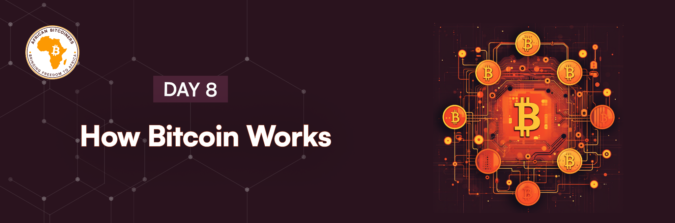

**Hello Friend,**

Compared to the day you signed up to take this course, we hope you at least have a better understanding of Bitcoin now.

Bitcoin lets people exchange money electronically as easily as sending an email or text. To send money, you use a “Wallet” app to type in an amount, enter or scan a recipient’s receiving address and hit “Send”. The recipient will then see the money pop up in their account. Every time you hit “Send”, your Wallet app sends a message to the Bitcoin network telling it how the ledger should change, the sender’s and recipient’s public address, and the amount to transfer.

**So how does it work?**

At a basic level, Bitcoin is just a ledger with account numbers and balances. When we send you 100 satoshis, our balance goes down by 100 sats, and yours goes up by 100 sats. There’s no gold or government-issued money backing these numbers, just people’s belief that the numbers are worth something, and a system that prevents unfair changes.

**So, what prevents a thief from creating a message, transferring money from someone else’s address?**

When a new public address is created, it comes along with a private key. Think of the private key as your fingerprint, everyone has a different unique fingerprint and it is effectively impossible for someone else to have the same fingerprint as you. Each Private key is mathematically linked to an address that only the true account owner knows, and this key is used to create signatures. Using the fingerprint example again, one's fingerprint can be used as a signature because it is unique and cannot be duplicated. The fundamental goal behind a signature is to have something one-of-a-kind that no one else can duplicate. If it can be replicated, then your signature can be used by someone else, right? This poses a security concern.

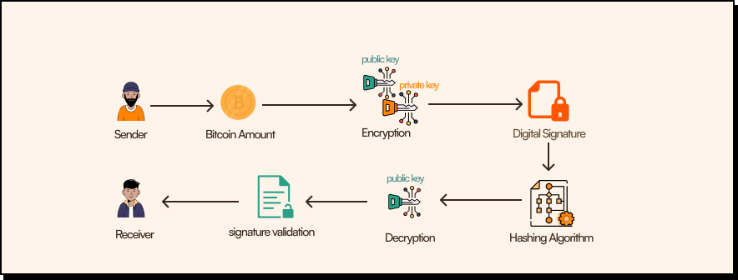

**Image showing how Bitcoin transactions are validated between sender to receiver.**

In Bitcoin, your private key and the transaction details are used to create a unique signature. Others can check this signature using your public address to make sure it's valid for that transaction.

Let us use another basic example: Imagine you have to sign an official paper to show you agree with what's written on it. The problem is, if someone can copy your signature exactly, they can do the same things you can with your signature. Isn't that bad? The Bitcoin signature serves the same purpose as a handwritten signature , but is based on math rather than handwriting. Unlike the handwritten version, these signatures can't be copied and reused in the future, as they're unique to each transaction. So, these signatures keep unauthorized transactions from changing the ledger. But who exactly is checking the signatures, and, overall, maintaining the ledger? Surprisingly, anyone who wants to.

As new transactions are created, they go into a pool of pending transactions (the Mempool as discussed on Day 7). From there, they'll be sorted into a giant chain (the blockchain) that locks in their order. To select which transactions are next, a kind of mathematical lottery is held by miners. They select a batch of pending transactions (usually those with the highest fees) and begin trying to solve a math problem that will link that block of transactions to the end of the chain every 10 minutes. The first miner to find a solution wins and gets to have the block of transactions they selected as the next block in the chain.

One of the main **goals of Bitcoin is to provide a decentralized system**, meaning no single company or government can control it. Every time someone sends money, a transaction message is passed around to all the people who want to help maintain the ledger, by running a node. Each of these nodes keeps a personal copy of the ledger and updates it whenever they receive a new transaction with a valid signature. With ledgers spread all over the world, traffic delays (and occasionally fraud) can lead to differences in those ledgers.

**So how does the world decide which version to use?**Quite simply the longest chain, or put another way, the chain with the most proof of work, is always the one selected by the network. If two miners create a block at the same time these blocks will likely be a little different. The winner is decided when the next block is created based on which of the initial blocks this new block is built on. The longest chain wins and the other block is discarded.

**So, why math problems instead of something like emailing in votes to decide on a ledger?** Without a central authority to register voters, it would be hard to enforce one vote per person. A single person could create multiple accounts to vote more than once or even millions at a time - this is known as Sybil attack. The math problems prevent this by making each vote have a cost in computers and electricity. This means out-voting, or out-solving the majority to take over the ledger would effectively require out-spending the majority and this is an unlikely event. So, the math enables a fair vote in a decentralized system, you can think of this as democracy - government of the people, by the people, and for the people.

**Two more important details about how the Bitcoin network prevents someone from pre-solving a puzzle to win the race are:**

1. Each puzzle builds on previous answers, and the winner is not just the most recent solution, but the ledger version with the most total solutions.
2. The puzzles are also extraordinarily special in that there are no tricks to solving them faster, other than by buying more computers and electricity.

So, today you have learnt that Bitcoin is an electronic currency that’s based on a **collaboratively maintained ledger.** People transfer money by sending messages to miners describing where and how much money should move. Miners make sure that the messages are from the true account owners by checking digital signatures. And finally, the miners reach a consensus with each other through a math-based voting process.

[**Click here to take today's quiz**](https://bitcoiners.africa/day-8-quiz/)



**Do you know that you can earn sats by playing games?** [**Thndr games**](https://www.thndr.games/) **rewards you with sats for having fun.** [**Click here**](https://www.thndr.games/) **to learn more.**

**Have a sats-isfactory day!😉**

**African Bitcoiners**

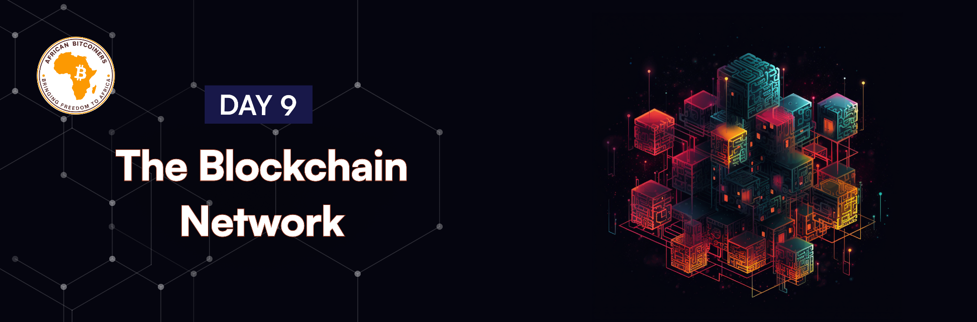

**Hello %FIRSTNAME%,**

Today we will be learning about the blockchain and the technology that keeps the Bitcoin system as transparent as possible.

Ever wondered if there's an easier way to complete transactions without having to deal with online wallets, banks, and third-party applications? Well, it's possible, thanks to the Blockchain.

A blockchain is a decentralized ledger of all transactions across a peer-to-peer network. Let’s look at this example to understand more about the blockchain. Ray, Ted, Sam, and Kelvin. Each of them possesses a magical ledger where they jot down their transactions, balances, and every entry made on one ledger synchronizes across all ledgers, and cannot be erased. This way, everyone is constantly updated about each others account balances and transactions.

One day, these friends decide to dine out. Before heading to the restaurant, they all had 20 sats in their accounts. At the end of the meal, Ray settles the 20 sats bill, which was automatically recorded in the ledger. To split the expense equally among themselves, the remaining friends, starting with Kelvin, send 5 sats each to Ray.  
In Bitcoin, as mentioned previously, a transaction involves sending Bitcoin to a Bitcoin address, and must be signed by the sender with a private key that only the sender knows.

After Ray pays the 20 sats bill Kelvin, Ted and Sam still have 20 sats each while Ray has nothing left.

Kelvin and Sam initiates a transfer of 5 sats each to Ray, and this transaction is securely and immutably documented in their ledgers. This record not only confirms the transfer but also updates the sats balances of both Kelvin, Sam and Ray, leaving them with 15 sats, 15 sats and 10 sats, respectively. This transaction is permanently recorded in their ledgers, ensuring transparency and accountability.

Now, here's where the ledger's magic truly shines. If Ted claims to have made a payment to Ray when, in reality, he hasn't, his deception would be exposed. All four friends can easily verify each other's sats balances and transaction history on the ledger, making it impossible to hide or manipulate the truth. This is one of the remarkable aspects of the Bitcoin blockchain – trust and transparency among users.

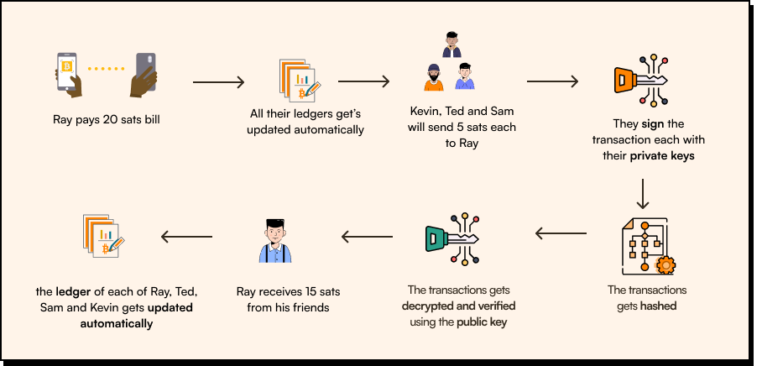

How Bitcoin transaction works

A hacker will not be able to alter the data in the blockchain because each user has a copy of the ledger and the data within the blocks is secured using a cryptographic hash function known as Secure Hash Algorithm -256 (SHA-256).

This function (SHA-256) takes a block's contents as input and returns a fixed-size output known as a hash. The hash of each block is included in the next block in the blockchain, forming a chain of blocks that cannot be changed without also altering all subsequent blocks. All of this is made possible with the help of blockchain technology, and so the blockchain can be described as a collection of records linked with each other and strongly resistant to alteration and protected using cryptography.

Let’s take a closer look at the transaction between Ray and Kelvin. Every user in the Bitcoin network has two keys: a public key and a private key. The public key is an address that everyone in the network knows like an email address of a user, while the private key is a unique address that only the user knows, something like a password.

As Kelvin sends Bitcoin to Ray’s Bitcoin address, the transaction is digitally signed by Kelvin’s private key through a hashing algorithm to indicate that the transaction came from Kelvin. The transaction is now sent to Ray's public address and can only be decrypted by Ray's public key, which only Ray knows. This transaction is then validated and added to a block by miners.

For a block to be validated and added to a blockchain, miners need to solve a complex mathematical problem. The miner who solves this first adds the block to the blockchain and is rewarded with 6.25 Bitcoins (It’s important to note that this reward amount has changed over the years through what is called “Bitcoin Halving”. We’ll touch on this important topic later). The process of solving a complex mathematical problem is called proof of work and the process of adding a block to the blockchain is called mining. With this process, Kelvin and Ray’s wallets are updated just like every person in the network who has completed a transaction.

We’ve discussed a lot of new concepts in the past few days. If you need to go back and re-read the lessons, please do.

[**Click here to take today's quiz**](https://bitcoiners.africa/day-9-quiz/)



Sost is a marketplace for talent. A platform that facilitates Bitcoin payments, providing freelancers with a way to earn bitcoin for their skills and time. [Click here](https://sost.tech/) to check them out.

**Have a great day!**

**African Bitcoiners**

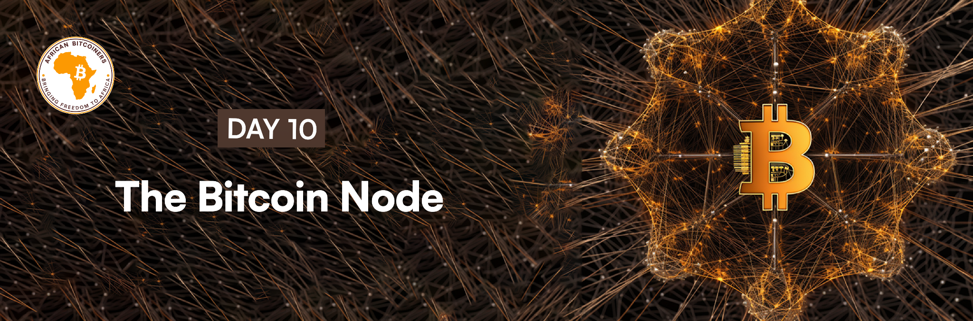

***As-Salaam-Alaikum* %FIRSTNAME%,**

Today we are going to have a short lesson as you’ve been taking so much in over the past 10 days.

**Blockchain nodes**

A node is a vital part of blockchain technology. A Bitcoin node is usually connected to the blockchain and holds a complete history of the Bitcoin blockchain, so it's safe to say that a Bitcoin node acts like a ledger that allows anyone to transparently see the transactions that are recorded on the network. A Bitcoin node also contributes to the security of the Bitcoin network through a consensus mechanism that sets and enforces the Bitcoin protocol rules about which transactions and blocks are valid and which transactions and blocks are invalid.

**Any computer that downloads the Bitcoin software or is connected to the Bitcoin network, keeps a record of all transactions, and helps validate transactions that adhere to the Bitcoin protocol rules, is called a node.**

These nodes are usually devices which include servers, computers, laptops, online or desktop wallets, and even mobile phones.

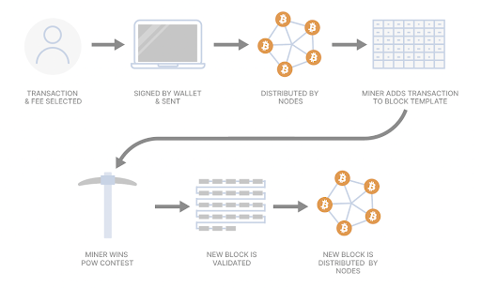

**Image showing the function of Bitcoin nodes**

**There are 3 major kinds of nodes in the Bitcoin network:**

**A light node is smaller in size** and only holds information about partial blockchain histories. This can also be called an SPV node. It doesn’t store the whole blockchain, only a tiny part of it. Light nodes download block headers (a section in a block that summarizes the rest of the block) to verify data and then transactions.

**A full node keeps a copy of an entire blockchain history** including every transaction on the network, timestamps, and all created blocks. Full nodes verify transactions, accept new blocks, and then broadcast the new transaction to other nodes. There are other reasons that encourage people to run a full node, such as contributing to the overall security of Bitcoin’s network and increasing the security of transactions, which is crucial if you plan to conduct numerous bitcoin transactions or transfers in a day.

**There is another specialised node called a miner,** which is a computer that solves a mathematical puzzle and adds transactions to a block. They receive transaction fees and block rewards in exchange for adding this transaction to a block. The nodes and miners work hand-in-hand.

Nodes relay the transactions in the mempool to miners and after the computational puzzle is done on the transactions, miner gets a block reward and then sends it to nodes to verify that the miners still adhere to the bitcoin protocol rules and share with other nodes in the network. While Bitcoin full nodes verify transactions, they do not receive the block rewards.

[**Click here to take today's quiz**](https://bitcoiners.africa/day-10-quiz/)



Yzer is a free gamified Bitcoin & Money education app. Users earn sats by completing lessons and completing various educational challenges. [Click here](https://yzer.io/) to start earning!

That's it from us today!🤓

Stay stacked

**African Bitcoiners**

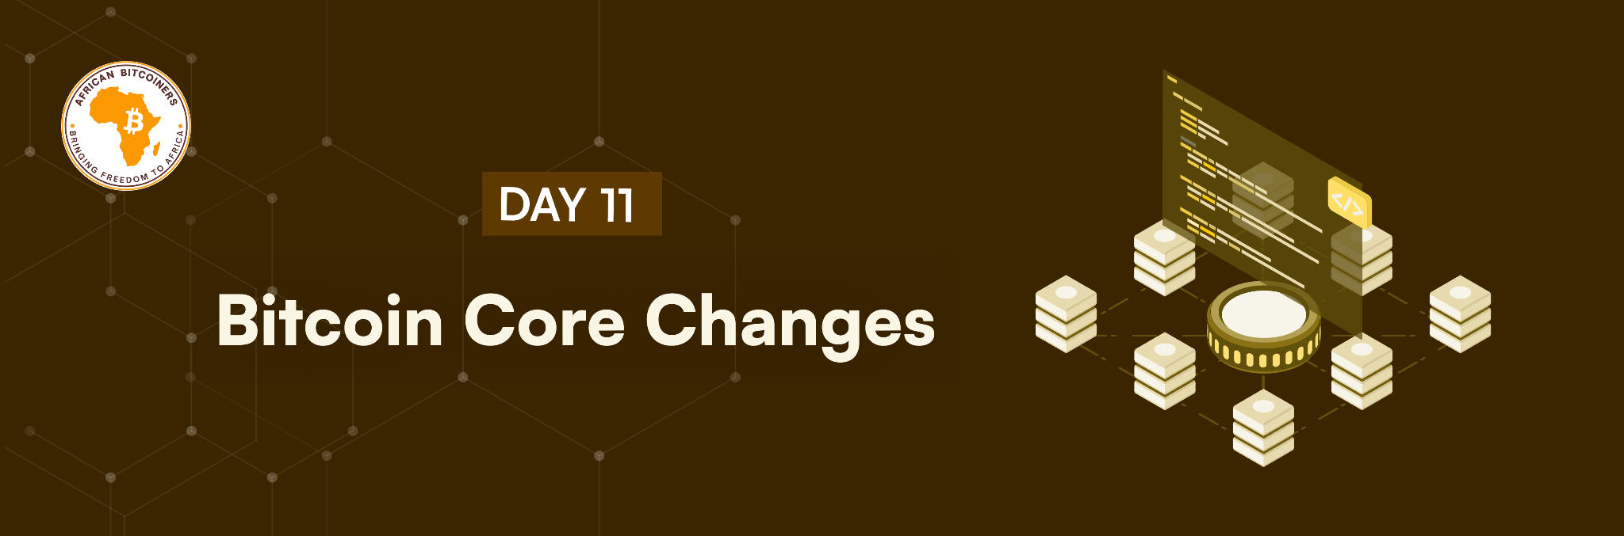

**Teanastëllën %FIRSTNAME%,**

**Today, we are looking at how changes are made to the Bitcoin core.**

Have you ever upgraded your WhatsApp? Maybe because there was a new version with brand new emojis or better features than the version you were using?  
  
It is the same for Bitcoin. The Bitcoin core software which is written in C++ programing language gets updated when the need arises, and users and nodes may need to upgrade too. Bitcoin Core is the reference implementation of the Bitcoin software, and updates or changes to it are not mandatory for users. Users have the freedom to choose whether to adopt new versions or stick with the existing one. However, staying updated with the latest releases is generally recommended for security, performance, and compatibility improvements. Before any change is made to the Bitcoin Core (or repository), there has to be consensus from the Bitcoin community of contributors and maintainers. **Changes to the Bitcoin repository can be made in 2 ways:**

1. **Hard Fork:** This is a change to the Bitcoin software that requires all nodes or users to upgrade to the latest version of the Bitcoin software because it is a permanent change from the previous version of the Bitcoin core and the old version is no longer compatible with the new version.
2. **Soft Fork:** In a soft fork, the newer version of the Bitcoin core is backwards-compatible with the old version. meaning that the upgraded nodes can still communicate with the non-upgraded ones. So, miners decide whether they want to upgrade to the new protocol and update their machines and eventually, if approved by the majority of miners, at a predetermined block number, the changes will be made official and this is how miners will verify blocks from that point on unlike many other protocols.

**But what happens to everyone’s Bitcoin from the previous version if a change is implemented to the Bitcoin Core?** Every change that is made to the Bitcoin Core needs to be backwards compatible, which means that if someone holds bitcoin, their Bitcoin will still be valid after the changes.

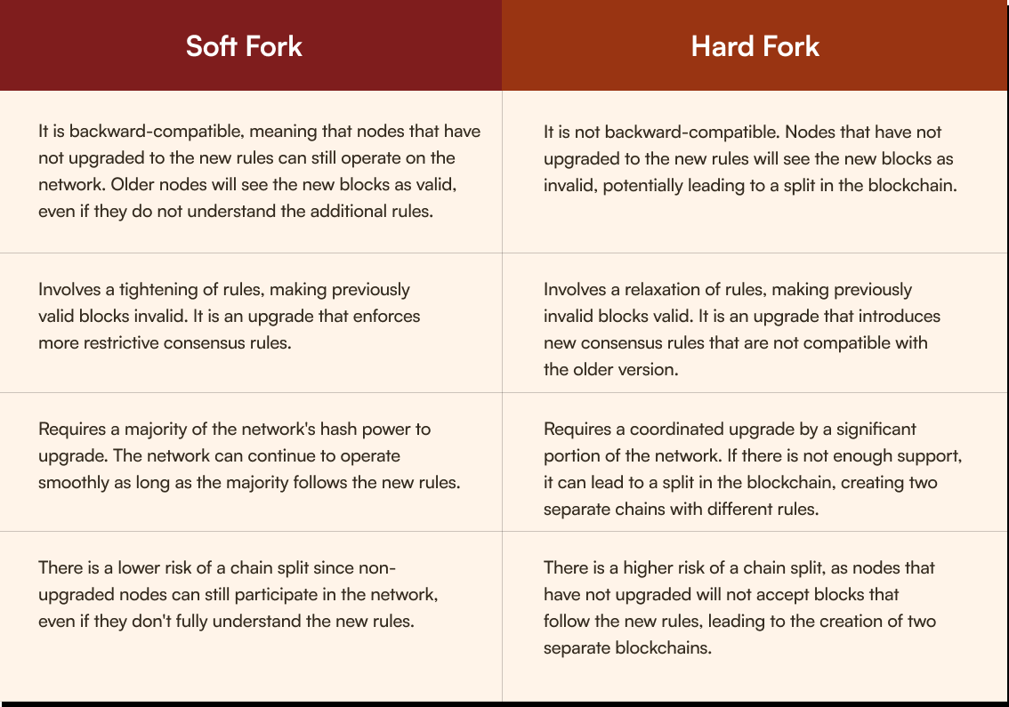

**Difference between hard fork and soft fork**

Some crypto networks allow for more flexible and frequent updates or changes to their protocols and often times, these changes are made without consulting their community. These changes may not be compatible with the older versions of the network. In practical terms, if a crypto network undergoes a non-backward compatible upgrade, users holding the coin might face challenges.

Imagine a crypto network introduces a major upgrade, making the existing coins incompatible with the new version. Holders of the coin must transfer their assets to platforms that support the updated protocol before a specified date. Failure to do so might result in the loss of their coins.

**Because all Bitcoin changes need to be backwards compatible, it makes implementing changes harder.** There is also no management team who “have the community’s best interest at heart” who will decide what new vision they have for their coin and implement changes regardless of what the community thinks.

The fact that Bitcoin is so difficult to change makes it a great asset for the long run. Buyers know what they're buying, and they know that the asset will remain the same. No other asset in the world provides this level of security. As it is decentralised, no one controls the Bitcoin network. It is an open secure network controlled and improved by every participant.

Compared to Bitcoin, some cryptocurrencies opt for hasty hard forks to introduce changes swiftly. This approach poses several dangers like a split in the blockchain, creating two separate chains with different rule sets, disagreements among community members on the fork can result in fragmentation, diminishing the network's strength.  
  
**Let’s talk about the risk that comes with uncontrollable and centrally approved changes to a crypto network.**Bitcoin Cash emerged in 2017 as a result of a heated scaling debate within the Bitcoin community. Disagreements over block size limits led to a faction advocating for larger blocks to accommodate more transactions quickly.

The contentious hard fork on August 1, 2017, resulted in the creation of Bitcoin Cash. While proponents believed it would address scalability issues and provide faster, cheaper transactions, others viewed it as a divergence from Bitcoin's original principles.

Over time, Bitcoin Cash experienced increased centralization of mining power. A small number of mining pools came to dominate the network, raising concerns about security and decentralization.

In November 2020, Bitcoin Cash fell victim to a 51% attack. Malicious actors gained control of more than half of the network's mining hash rate, allowing them to manipulate transactions, double-spend coins, and potentially cause network disruptions.

The attackers exploited their majority control to execute double-spending attacks, undermining the integrity of transactions. Exchanges and users were exposed to the risk of accepting manipulated transactions as valid. The 51% attack had severe repercussions on Bitcoin Cash's market value.

Today we covered how changes are implemented on Bitcoin Core. Put your knowledge to the test.

[**Click here to take today's quiz**](https://bitcoiners.africa/day-11-quiz/)



Check out [BTC Transcription Review](https://review.btctranscripts.com/home) where you can earn sats for reading and editing technical Bitcoin transcripts.

Till tomorrow. **African Bitcoiners**

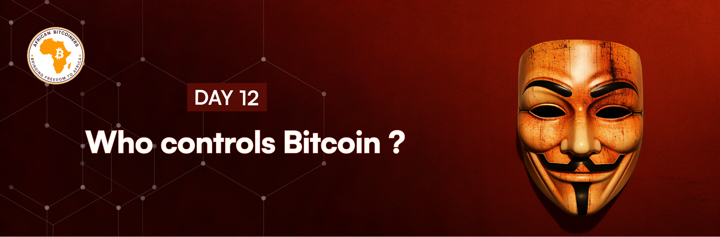

***M’bole* %FIRSTNAME%,**

Remember yesterday when we learned about how changes are made to the Bitcoin core or repository? Well, today is a special day because you have 9 days left to finish this course, and we’re spilling the tea on who controls the Bitcoin core. Bitcoin is controlled by no one and validated by everyone who runs a Node.

**So absolutely no single person controls Bitcoin.**

But what about the Bitcoin source code?😕  
What if someone makes unauthorised changes? 😟

Who exactly controls the ability to merge code changes into Bitcoin’s GitHub repository? 😏

How is the core protected, and how hack-proof is it?😬  
How exactly does it operate?😱  
  
So many questions, you smart being! 🤓. Let's start with understanding the source code.

In essence, the Bitcoin source code operates as the blueprint for the entire Bitcoin network. It is open-source, meaning it is publicly accessible and can be viewed, modified, and distributed by anyone. The source code is hosted on GitHub, providing a collaborative platform for developers worldwide to contribute to its development.

Wait, if the Bitcoin source code is open-source would it mean everyone and anyone, can replicate the Bitcoin technology by copying and running the code?

**The answer is NO!**

Although anyone can copy and run the Bitcoin source code, they would essentially be creating a new cryptocurrency with its own separate network. This fork would not be connected to the original Bitcoin network, and users of this new cryptocurrency would not have access to the same ledger or transactions as the original Bitcoin. Therefore, while the source code is open for anyone to use, it does not mean that they can replicate the exact Bitcoin technology.

This is because the Bitcoin network is not just the code itself but also the network of users, miners, and nodes that support and maintain it. This is where the Bitcoin core comes in. The Bitcoin core acts as the interface for users to create nodes, store coins, and conduct transactions. Similar to how Google Chrome provides internet navigation features, Bitcoin Core shapes user interactions with the Bitcoin blockchain. While other Bitcoin software clients exist, none rival the widespread influence of Bitcoin Core. Its significance stems from being forked from the original software established by Satoshi Nakamoto, upholding the core ideology of Bitcoin. In essence, Bitcoin Core remains the foremost choice in preserving Satoshi's vision for the cryptocurrency.  
  
The Bitcoin Core is the bridge that connects the intricate web of users, miners, and nodes, facilitating the seamless operation and sustainability of the Bitcoin network. Its role in enforcing rules, validating transactions, and maintaining connectivity solidifies its position as a cornerstone in the resilience and success of the entire Bitcoin ecosystem. So replicating the entire Bitcoin technology would require not only copying the code but also building a similar network infrastructure and gaining widespread adoption.

Implementing changes to the Bitcoin core is not as simple as copying the code and implementing changes, yet Bitcoin is constantly evolving, and changes are constantly being made to the Bitcoin source code. So how are these changes made? These changes are made through a process called **Bitcoin Improvement Proposals (BIPs).** BIPs are proposals submitted by members of the Bitcoin community to introduce new features, improvements, or changes to the Bitcoin protocol. They undergo a rigorous review and discussion process within the community before being implemented. The beautiful part is that anyone can contribute to the development of Bitcoin by submitting their BIPs or participating in the review and discussion process.

**Who then implements these changes?**

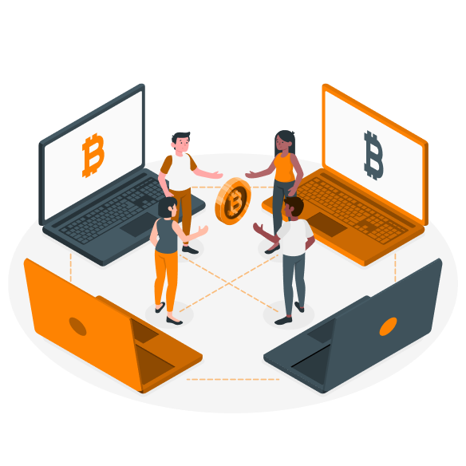

The implementation of Bitcoin Improvement Proposals (BIPs) into the Bitcoin Core software involves a collaborative and decentralized process within the Bitcoin development community.

**Here's a breakdown of the process:**

* **Submission by BIP Proposers:** Anyone in the Bitcoin community, including developers, enthusiasts, or businesses, can propose a BIP to suggest improvements or changes to the Bitcoin protocol.
* **Review by BIP Editors:** BIPs go through an editorial process where BIP editors review and refine the proposals. The role of BIP editors is to ensure that the proposals are well-formulated, adhere to the BIP template, and are technically sound.
* **Discussion by the Developer Community:** Bitcoin Core developers, who are part of the wider community, actively participate in the review and discussion of proposed BIPs. This collaborative process occurs on public forums, mailing lists, and occasionally in developer meetings.
* **Consensus Building:** Achieving consensus within the developer community is crucial. This involves discussions, debates, and sometimes multiple iterations of a proposal to address concerns and reach a broad agreement.
* **GitHub Pull Requests:** Once a BIP gains consensus, it may be implemented as a code change in the Bitcoin Core GitHub repository by the developers, This is a formal request to the maintainers of the main repository to "pull" or integrate the changes from the developer's branch into the master branch of the main repository.
* **Review and Discussion:** The pull request undergoes a thorough review process. Other developers, maintainers, and contributors examine the code changes, test functionality, and provide feedback. Discussion and collaboration take place within the comments section of the pull request.
* **Implementation by Bitcoin Core Maintainers:** Bitcoin Core has a group of maintainers who play a crucial role in implementing changes to the Bitcoin protocol proposed in BIPs. The maintainers review the proposed changes, assess their feasibility and impact, and work towards integrating them into the Bitcoin source code.
* **Peer Review:** The proposed code changes undergo thorough peer review. Other developers and contributors scrutinize the code, test its functionality, and verify that it aligns with the proposed BIP.
* **Bitcoin Core Release:** Accepted BIPs are eventually included in a new release of the Bitcoin Core software. This release is made available to the public, and users can choose to upgrade their nodes to adopt the improvements.

The Bitcoin development community continuously works on improving the protocol and addressing any issues that arise. The entire process of proposing, reviewing, approving, and implementing changes is decentralized, involving various contributors in the Bitcoin community.

Many are of the opinion that GitHub employees might inject code into the Bitcoin source code without consent from the maintainers. So, rather than base the integrity of the code on GitHub accounts, Bitcoin Core has a continuous integration system that performs checks of trusted PGP signatures on every commit made to the codebase. PGP (Pretty Good Privacy) signatures are cryptographic signatures that ensure that only authorized contributors can make changes to the code and help maintain the security and integrity of the Bitcoin Core software.

The Bitcoin maintainers have a leader and this position is transferred from one person to another in a process known as voluntary passing. This ensures that the Bitcoin Core software remains in capable hands and prevents any single individual from having too much control or influence over the codebase. This right first moved from Satoshi Nakamoto to Gavin Anderson and then to Wladimir J. van der Laan, who is the current maintainer of the Bitcoin Core software. Importantly, network participants can remove maintainers if they believe they are working against the community’s shared vision of the Bitcoin network.

**How hackproof is the Bitcoin core software?**

The Bitcoin Core software is designed to be highly secure and resistant to hacking attempts. It utilizes advanced cryptographic algorithms and follows best practices in software development to minimize vulnerabilities. However, no piece of software can be completely hackproof, and vulnerabilities can still be discovered and exploited. To mitigate this risk, the Bitcoin Core community actively conducts security audits, encourages responsible disclosure of vulnerabilities, and releases regular updates to address any identified issues.

Today, you have learnt that no one controls Bitcoin and the measures put in place to ensure changes to the Bitcoin repository are thoroughly scrutinised. Tomorrow, we will be talking about how you can become a Core contributor if that’s something you’re interested in.

[**Click here to take today's quiz**](https://bitcoiners.africa/day-12-quiz/)



| | If you enjoy writing, Y'alls is your chance to earn Bitcoin for your writing skills. [Click here](https://yalls.org/) to start earning.  Stay merry and bullish  **African Bitcoiners** | | --- | | |  | | --- | | |
| --- | --- | --- | --- |

| |  | | --- | |
| --- | --- |

| | ***Habari* %FIRSTNAME%**  Think you can add value to the Bitcoin Core?  Well, the Bitcoin community is open to contributions that will make the Bitcoin network better. There are no special requirements for becoming a digital currency developer, in fact, you don’t even need to be a developer to get involved. Anybody can join, leave, or choose the area of development they decide to focus on.  Africa has some notable contributors to the Bitcoin Core including [Abubakar Nur Khalil](https://twitter.com/ihate1999). The vast size of the Bitcoin Core’s development team coupled with the fact that developers do not have to disclose their identity before they are eligible to contribute makes coming up with a comprehensive list of Bitcoin Core developers, both present and past, very difficult.  If you decide to contribute to Bitcoin Core, the project has enough complexity and development work to keep anyone busy for many lives. Choosing how to allocate your attention will help determine what you don't want to focus on (at least not now). As we mentioned yesterday, not everyone is permitted to make changes to the master code except if a consensus is reached between the 5 Maintainers. This is done to preserve the integrity of the Bitcoin Core.  **The process of contributing**   1. Pull request security: Anyone is free to propose code changes to improve the Bitcoin Core software by cloning the Bitcoin Core to repository and adding the changes you want tomake to the cloned copy and then submit for review.  |  |  |  |  |  |  |  |  | | --- | --- | --- | --- | --- | --- | --- | --- | | | --- | --- | --- | --- | --- | --- | --- | --- | --- | |
| --- | --- | --- | --- | --- | --- | --- | --- | --- | --- |

**2.** Developers review pull requests to ensure they are not harmful. Anyone is free to review pull requests and provide feedback. There is no gatekeeper or entrance exam when it comes to contributing. If a pull request gets to the point that there are no reasonable objections to it being merged, a maintainer makes the merge.

Core maintainers try to ensure that they don’t push unsigned commits into the repository. Merge commits are optionally securely timestamped via Open Timestamps. The Travis Continuous Integration system regularly runs scripts to check the integrity of the GitHub tree (history) and to verify that all commits in the master branch were signed with one of the trusted PGP keys. The beautiful thing is that anyone who wants to, can run this script to verify the PGP signatures used for merge commits as far back as December 2015.

If the Bitcoin core is so hard to manipulate, how do Bitcoin developers test their apps functionality when building for Bitcoin?

Developers, enthusiasts, and anyone wanting to experiment with Bitcoin-related applications, software, or new features can use the Bitcoin testnet. It allows them to test various functionalities without the risk of using real Bitcoin. Transactions on the testnet are broadcast, confirmed, and recorded just like on the mainnet, but the coins used are distinctively different, ensuring that any mistakes or issues do not affect real funds.

[A Bitcoin testnet](https://bitcoinfaucet.uo1.net/) is a parallel network to the main Bitcoin blockchain, specifically designed for testing and experimentation purposes. It mirrors the functionalities of the actual Bitcoin network but operates with test bitcoins, which have no real-world value.

This environment is crucial for developers to test their applications, wallets, smart contracts (A self-executing contract with the terms of the agreement between buyer and seller being directly written into lines of code.), and other innovations before deploying them on the actual Bitcoin network. It aids in identifying and resolving issues, ensuring that when these applications go live on the mainnet, they operate as intended and securely handle real bitcoins.

**Who funds Bitcoin Core development?**

Funding for Bitcoin Core development comes from various sources, including organizations like Square Crypto, Chaincode, MIT DCI, Blockstream, Gemini, Coinbase, BitMEX, Hardcore Fund, as well as other notable contributors.

Don't forget to take the quiz

And if you’re interested in contributing to the Bitcoin network, find out more about how you can go about this:[https://bitcoin.org/en/bitcoincore/contribute/](https://bitcoin.org/en/bitcoin-core/contribute/)

[**Click here to take today's quiz**](https://bitcoiners.africa/day-13-quiz/)



Do you know you can earn Bitcoin for things you already do?

Smiles Bitcoin will reward you with Bitcoin for walking, shopping, playing games, and taking surveys. [Click here](https://www.smilesbitcoin.com/) to start earning😍.

Chat tomorrow!

**African Bitcoiners**

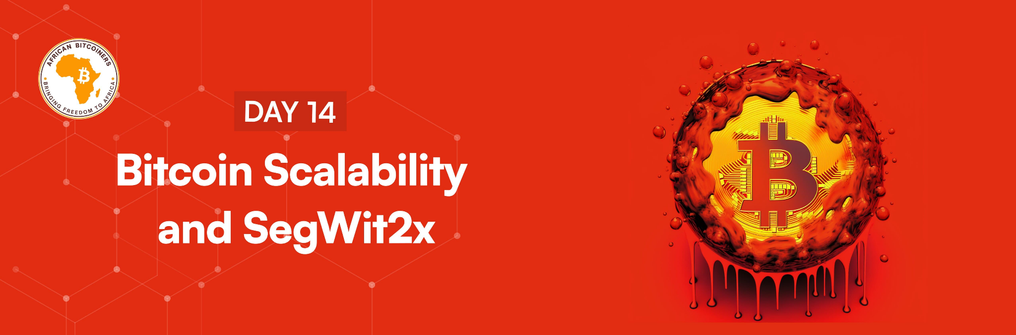

**Muraho %FIRSTNAME%,**

Once upon a time, the blockchain scalability trilemma was one of the greatest hurdles for cryptocurrencies because it was assumed that a cryptocurrency can only achieve 2 out of 3 of either decentralisation, scalability, or security simultaneously, but never all 3 at once. Trade-offs are inevitable. Initially, Bitcoin traded off scalability to ensure the network remained decentralised.

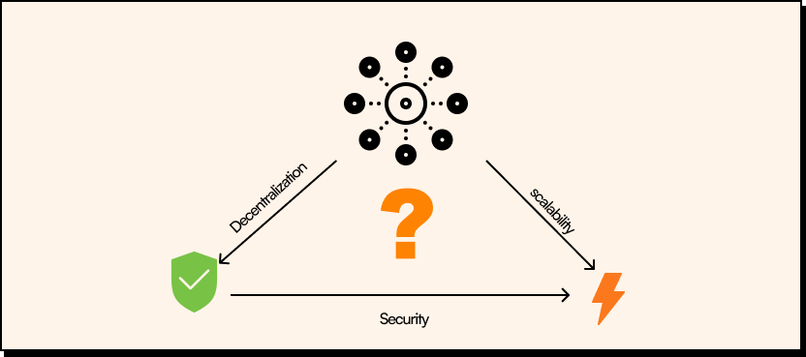

Image showing Scalability trilemma

The Bitcoin scalability problem refers to the confined functionality of the Bitcoin network to handle large amounts of transaction data on the network within a short period of time. It is related to the fact that records (called blocks) in the Bitcoin blockchain are confined in size and frequency.

Bitcoin's blocks contain the transactions on the Bitcoin network. The on-chain transaction processing capacity of the network is limited by the average block creation time of 10 minutes and the original block size limit of 1 megabyte. These jointly constrain the network's transaction processing time. The maximum transaction processing capacity estimated using an average or median transaction size is between 3.3 and 7 transactions per second. The block size limit and the proof-of-work difficulty adjustment settings of Bitcoin's consensus protocol became the greatest limitation of the network as more people adopted the technology.

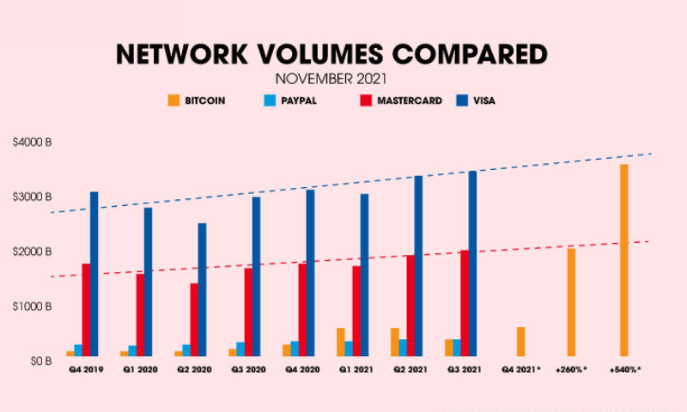

Image showing Bitcoin network volume compared to that of other payment services.

Solving this problem became a pivotal moment in Bitcoin’s history. Remember day 11 when we shared that Bitcoin cash was a hard fork solution to solve the Bitcoin scalability problem by increasing the block size in the blockchain. After implementing this, the Bitcoin blockchain was divided into two separate blockchains: one maintained in accordance with the rules currently valid for Bitcoin, and the other maintained in accordance with the rules currently valid for Bitcoin Cash. If one had coins on the Bitcoin chain prior to the fork and had not yet moved them, one could move them on one or the other or both chains. Thus, all holders of Bitcoin also became holders of Bitcoin Cash at the time of the split. Henceforth Bitcoin and Bitcoin Cash are separate and trade at entirely independent valuations relative to each other, fiat currencies, and other assets.

[Segregated Witness](https://youtu.be/ui9JwnB1d-k), a soft fork solution was also proposed. Most Bitcoin Core developers considered increasing Bitcoin's block size limit risky (a way of increasing transaction capacity) and preferred to have Bitcoin grow by adding new protocol layers on top of Bitcoin's blockchain originally intended as a compromise between the opposing sides. Bitcoin Core developers proposed a protocol upgrade called Segregated Witness also known simply as SegWit. SegWit fixed the transaction issue in the Bitcoin protocol by separating out the witness data giving an effective block size increase through a soft fork. In the process, SegWit also enabled a particularly clever type of transaction layer called the Lightning Network.

SegWit could be deployed as a soft fork with a backwards compatible (older version of the Bitcoin can work with the upgraded version) type of upgrade allowing users to opt in if, and when they want to, therefore minimizing the risk of partitioning the network between upgraded and non-upgraded nodes to guarantee the safety of such an upgrade. Soft fork activation was usually coordinated through hash power. Once most miners signaled to be ready for the upgrade, it would activate across the network. But when SegWit was ready to be activated by late 2016, some major miners decided not to cooperate. They tried to block the soft fork, demanding it be paired with a backwards-incompatible (older version of Bitcoin will not work with the upgraded version) hard fork upgrade to further increase the block size limit. Adding to the risks of even bigger blocks, this type of upgrade had a much bigger risk of partitioning the network.

Because of the controversial nature of this request, the miner's demand was off the table for Bitcoin Core developers. As miners continued their blocking, users were left waiting for SegWit. A few months went by until a pseudonymous developer, Shaolin Fry had an idea that’d break the deadlock.

In early 2017, he dropped a new proposal to the Bitcoin development mailing list and the popular bitcointalk.org forum, a user-activated softwork (UASF) proposal.

A user-activated softwork would include a flag day which is a specific day in the future from which point on, Bitcoin users would start enforcing the SegWit upgrade instead of miners coordinating the upgrade. Miners were given a deadline. If they failed to meet that deadline, the users would start rejecting their blocks. This proposal caused a buzz across Bitcoin news sites, forums and social media. Shaolin Fry, with a group of maybe several dozen Bitcoiners, gathered in an open Slack channel to contemplate what such a UASF would look like exactly. It became a central point for discussion and the Bitcoin Improvement Proposal(BIP) was drafted to be numbered BIP 148 and a flag day was picked; 1st of August 2017.

The 1st of August UASF flag day turned into somewhat of a viral phenomenon, by summer, many users had come to conclude that while miners could stop a specific upgrade mechanism, miners couldn't block SegWit itself. USERS not MINERS defined Bitcoin's Protocol and because of this powerful realisation, 1st of August was dubbed Bitcoin Independence Day, and in the end, BIP 148 played out perfectly because it didn't need to be tested to its full extent. About a week ahead of the 1st of August, Miners activated the SegWit upgrade on their own and with this Bitcoin's block size limit was increased and the protocol was readied for the Lightning Network and other layer 2 solutions.

Although Miners ultimately activated the upgrade ahead of the Flag Day deadline, the 1st of August was carved into Bitcoin’s history as the day users celebrate their sovereignty over Bitcoin miners.

So yes, Bitcoin has had its share of battles and challenges and has persevered!

[**Click here to take today's quiz**](https://bitcoiners.africa/day-14-quiz/)



You can host a podcast for free on BTC podcasting and immediately start receiving sats from your listeners. [Learn more](https://btcpodcasting.com/).

See you tomorrow.

**African Bitcoiners**

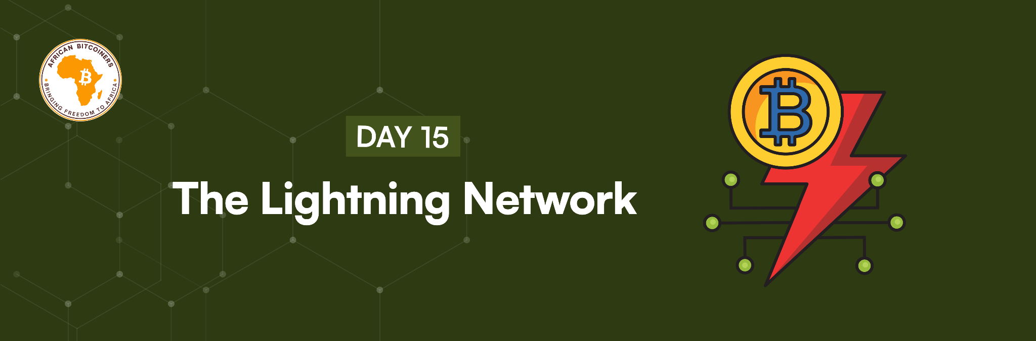

**Hoe gaan dit %FIRSTNAME%?**

Bitcoin is getting adopted by so many, and when Bitcoin becomes adopted by a lot more people and a couple of million people decide to start using the network daily, the blockchain which serves as Bitcoin's "base layer," will be unable to support enough daily transactions for billions of users.

The transaction queue and fee rate would quickly increase as users compete to have their transactions processed and that would be a huge challenge for Bitcoin. This could easily be solved using a centralized system approach but that would be against what Bitcoin stands for as transactions could be censored and privacy compromised. To help solve this problem, a system called the lightning network was developed and deployed on top of the Bitcoin Blockchain as a second layer to allow the network to expand to handle the anticipated exponential growth in transaction quantities.

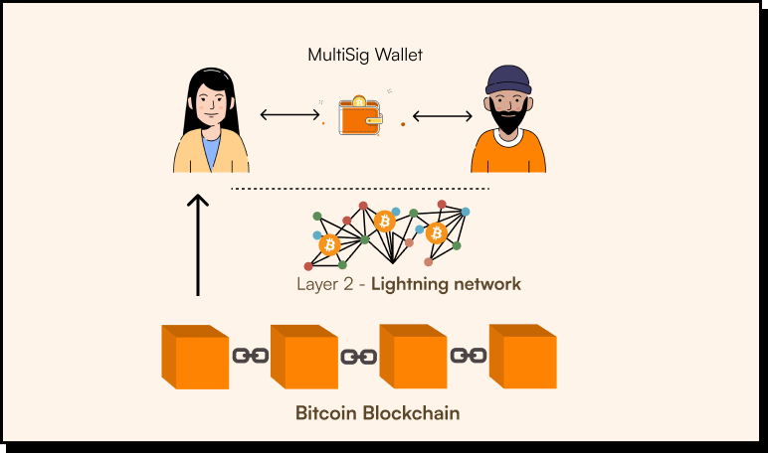

Illustration of the Lightning Network

The lightning network is a special second layer (layer 2) of the Bitcoin blockchain that allows faster payments using an "off-chain protocol" and additional functionality to Bitcoin. It is a solution to scaling that enables participants to speed up Bitcoin transactions to attain an almost instant speed at a very little cost and can make very small Bitcoin payments while still retaining many interesting qualities of Bitcoin, such as non-custodial transactions and settlement, at very little transaction fees compared to onchain transactions.

The Lightning Network is a network of payment channels between Lightning nodes. By routing payments through these Lightning nodes and only settling (channel closes) to the Bitcoin blockchain, Lightning enables many more Bitcoin transactions per second at a far cheaper cost than doing standard on-chain Bitcoin transactions. Picture this: you enter a store or mall to purchase some items like shoes, bags, caps, and belts. You then proceed to pay for the items one by one instead of calculating the items together and paying for them once. By paying once, you would save a lot from the transaction and tax charged by the store compared to if you were paying for each item separately. So, the lightning network works similarly to paying for the items once. One trade-off required with Lightning Network participants is that they must be online for transactions.

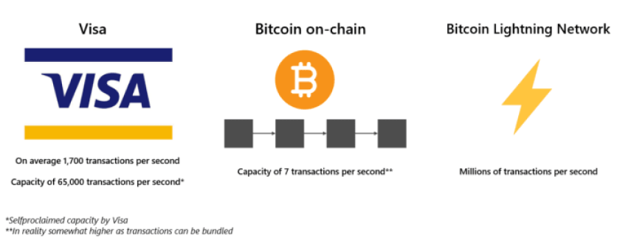

In practice, if you are planning to use Bitcoin for "day-to-day" spending, then definitely consider using Lightning payments rather than onchain transactions. This will result in a much smoother experience for you. For larger value transactions (over a few thousand dollars) we recommend on-chain payments.  
  
**Lightning node and how to set up a lightning Node:**  
A Lightning node is a piece of software that links to the main blockchain network and the Lightning Network.  
  
A Lightning Network node has 2 responsibilities:

1. Monitor the first layer of the Bitcoin blockchain.
2. Interact with other Lightning Network nodes to transact money.

Running your own Lightning node is more for Bitcoin professionals or super users since it requires a bit of technical capability and learning. To run your own Lightning node, you will need to set up your own channels and manage liquidity and backups which will take further research and work. You can read more about it [here](https://africanbitcoiners.lt.acemlna.com/Prod/link-tracker?notrack=1&redirectUrl=aHR0cHMlM0ElMkYlMkZibG9nLmJpdGZpbmV4LmNvbSUyRnRyYWRpbmclMkZ0aGUtbGlnaHRuaW5nLW5vZGVzLWEtYmVnaW5uZXJzLWd1aWRlJTJG&sig=6FCR5KWaSDPLL3KbVemnq9Ea4UrRyH4Qv8BXspAH3pJo&iat=1705504392&a=%7C%7C651665555%7C%7C&account=africanbitcoiners%2Eactivehosted%2Ecom&email=JRj3FuHAkti7TQ%2FgSVbPkfiOnfqbaoBRhtJprRT3cH8HS%2BqBWU%2BfyQ0MY8U%3D%3AlHKtcSR%2Fky4wRea9QyK9leOqFrHI3U4z&s=b56bde605b8557a9ece4a74e56668cdf&i=20A22A0A1554) or you can check out [Africa Free Routing](https://africanbitcoiners.lt.acemlna.com/Prod/link-tracker?notrack=1&redirectUrl=aHR0cHMlM0ElMkYlMkZmcmVlcm91dGluZy5hZnJpY2ElMkY=&sig=Fp8oVHd8XTcb59xgmrVsUS7dBv6r33LzW1g7QWtTcQAH&iat=1705504392&a=%7C%7C651665555%7C%7C&account=africanbitcoiners%2Eactivehosted%2Ecom&email=JRj3FuHAkti7TQ%2FgSVbPkfiOnfqbaoBRhtJprRT3cH8HS%2BqBWU%2BfyQ0MY8U%3D%3AlHKtcSR%2Fky4wRea9QyK9leOqFrHI3U4z&s=b56bde605b8557a9ece4a74e56668cdf&i=20A22A0A5919) was they are bringing the lightning network to Africa.

Extra reading: [More in-depth reading on the lightning network](https://bitcoiner.guide/lightning/)

[Click here to take today's quiz](https://bitcoiners.africa/day-15-quiz/)



We are still on the Million Sat Challenge! How much have you stacked so far? We will like a feedback on how you are getting along on the challenge.

Your lightning loving friends.

**African Bitcoiners**

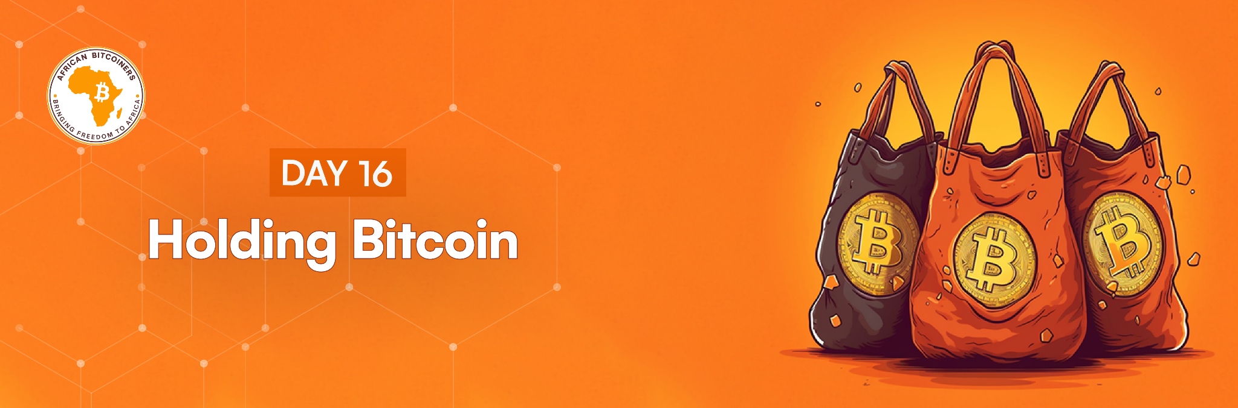

**Wetin dey sup %FIRSTNAME%?**

Today, we want to teach you about an important aspect of Bitcoin: holding the keys to your own Bitcoin so you are always on the safe side.

The Bitcoin network is like a series of deposit boxes at a train station. Everyone has access to and can see into the deposit box via the slit. They can also deposit bitcoin. To open the box, each box has its own pin code. This is called the private key. Each box also has a number to identify it, this is called the Bitcoin address and the Bitcoin address is visible to everyone. The Bitcoin address is like your email address, public and visible to everyone but the password used to access it is the private key. Each box is actually transparent, and anyone can see the number of bitcoins in it, but only you have access to the box because only you have the private key.

Let’s talk about the 4 most important things:

1. Private Keys

2. Public Keys

3. Bitcoin addresses

4. Digital signatures

**Private Keys:** A private key in the context of Bitcoin is a secret, alphanumeric code known only to the owner. It acts as a digital signature and is crucial for authorizing transactions. If you think of your Bitcoin wallet as a vault, the private key is the unique combination that unlocks and controls the funds inside. It should be kept secure and not shared with anyone.

**Public Keys:** The public key is derived from private key through elliptic curve cryptography (ECC), a one-way cryptographic function. This process is irreversible, meaning you can't easily go from the public key back to the private key. If the private key is the key to the vault, the public key is like a public address or a signboard indicating where others can send funds. It's visible to anyone on the Bitcoin network.  
  
The private key and public key form an inseparable pair known as **digital keys.**

In traditional security practices, a single password is commonly used for both securing and accessing a document. Yet, in Bitcoin's context, the process differs significantly. Here, two keys are employed: one for receiving funds, and the other for managing the received coins.

The key used to receive Bitcoin, known as the public key because it can even be shared or published on the internet. On the other hand, the private key remains confidential, accessible only to you, and its sole purpose is to open your Bitcoin wallet, providing you with access to your funds.

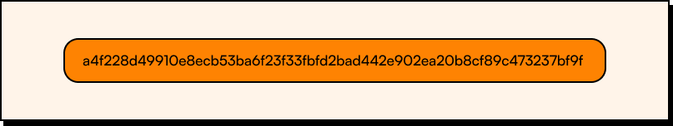

Image showing an alphanumeric private key

**Private Keys in Recent Times**

As Bitcoin has evolved, private keys have transitioned from alphanumeric characters to seed/mnemonic phrases. These phrases, present in Bitcoin deterministic wallets and typically comprising 12 to 24 words, have revolutionized the way individuals secure their Bitcoin holdings.

Unlike the traditional method of using a single password for locking and unlocking, this seed phrase simplifies the process of securing your Bitcoin by condensing the complexity of private keys into a human-readable and easily manageable format.

Aligned with BIP 39 standards, these words possess the capability to regenerate your entire Bitcoin wallet. In the unfortunate event of a lost wallet or device malfunction, this seed phrase serves as a failsafe mechanism. Restoring access to your funds becomes a straightforward process by inputting this mnemonic sequence into another BIP 39 compatible wallet.

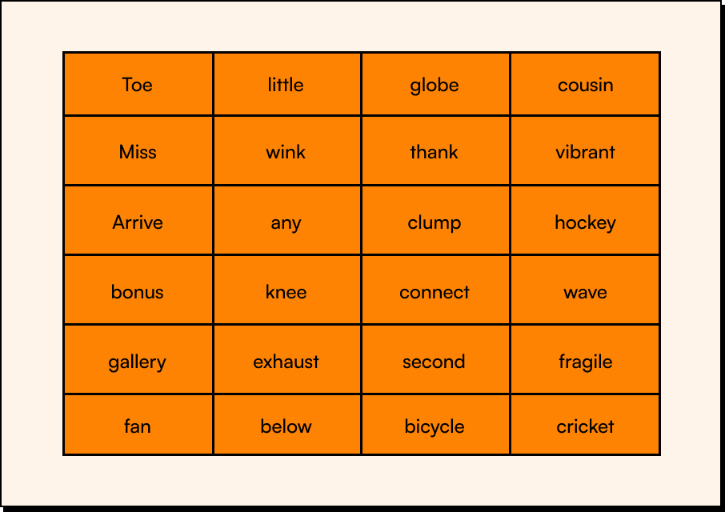

An example of seed phrases

**Bitcoin Addresses:** A Bitcoin address, just like a private and public key is an alpha-numeric long string of characters that can be shared with anyone who wants to send you money, in this case, Bitcoin. They are derived using the SHA-256 cryptographic hash function. Think of a Bitcoin address as a bank account number it serves as a means for people to direct funds to you in the form of Bitcoin. It is derived from your public key using a one-way cryptographic hashing function and are distinctive in the sense that they often start with specific prefixes, each carrying its own significance. Bitcoin addresses fall into three main categories:

1. **Addresses that begin with "1"**: These are the most common Bitcoin addresses and are derived from standard public keys.
2. **Addresses that begin with "3":** These are associated with a more advanced form of Bitcoin transactions, often involving multi-signature or complex script-based transactions. They are less common but offer added security feature.
3. **Addresses that begin with "bc1"**: These addresses are part of the newer Segregated Witness (SegWit) format and are designed to improve Bitcoin's efficiency and reduce transaction fees.

The image below shows what a Bitcoin address looks like, notice that, as mentioned before, each address begins with either “1”, “3” or “bc1”

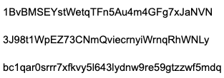

**Note: Do not send Bitcoin to any of the above addresses; they are not real addresses and are used as an example to get an idea of what a Bitcoin address looks like**

**Digital Signatures:** Every transaction requires a valid signature to be included in the blockchain, which can only be generated with valid digital keys. Think of a digital signature as the electronic equivalent of your handwritten signature on a physical document, but with an added layer of cryptographic sophistication.

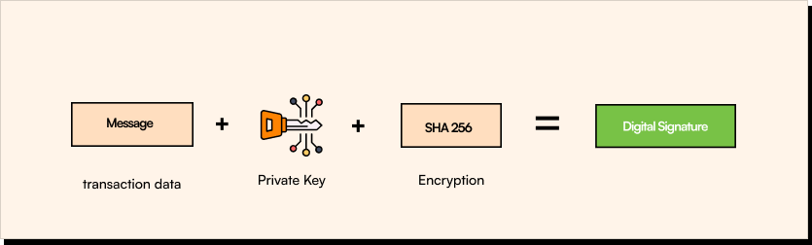

Image showing how digital signatures are derived

When you initiate a Bitcoin transaction, whether it's sending or receiving funds, it must be verified and recorded on the blockchain. But how can the network be sure that the transaction is legitimate and authorized by you? To validate the transaction and ensure that it's genuinely coming from you, your private key generates a digital signature for that specific transaction. This digital signature is a complex mathematical representation of the transaction data, created in a way that is unique to your private key. It serves as proof that you are the rightful owner of the funds and that you have authorized the transaction.

To be accepted into the Bitcoin blockchain, every transaction must be accompanied by a valid digital signature. The network checks the signature against your public key to confirm its legitimacy. If the signature matches the public key, the transaction is considered valid and is added to the blockchain. Cool right?

Ok, that’s enough for today, tomorrow we will talk more about wallets.

[Click here to take today's test](https://bitcoiners.africa/day-16-quiz/)



Another great place to earn sats is [Stacker news](https://stacker.news/). You can earn sats for writing cool Bitcoin contents or even for your comment on someone else's content. [Click here](https://stacker.news/) to check it out.

Have a great day!

**African Bitcoiners**

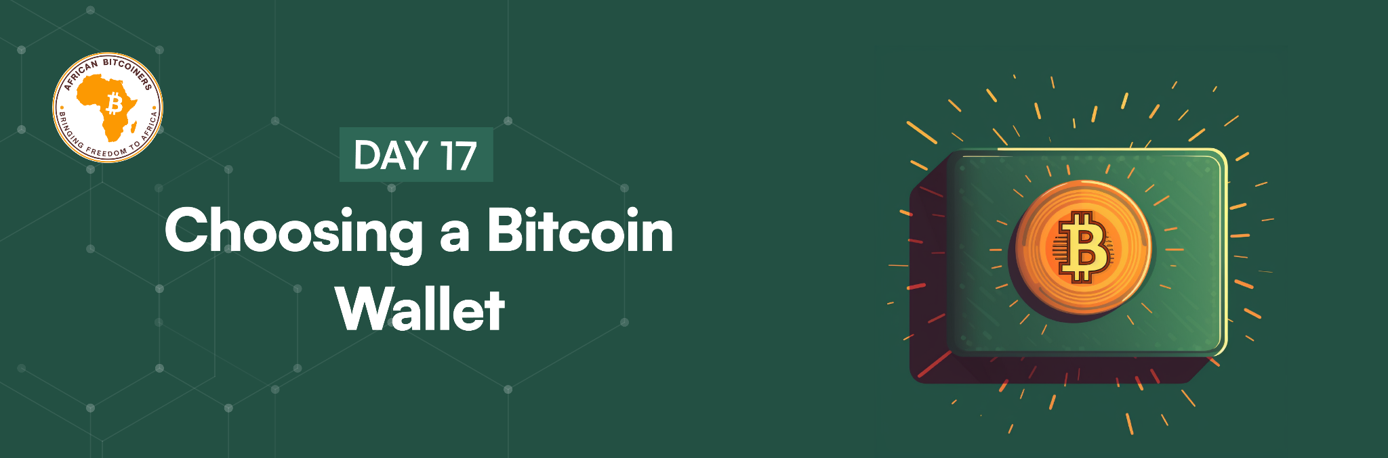

**Hello %FIRSTNAME%,**

You’ve learnt a lot about the theories of Bitcoin, today we are going to explore the rabbit hole of Bitcoin wallets. To access your bitcoin, you need a wallet.

Bitcoin wallets are one of the most actively developed applications in the Bitcoin ecosystem. There is intense competition, and while a new wallet is probably being developed right now, several wallets from last year are no longer actively maintained. Many wallets focus on specific platforms or uses – for example, some are more suitable for beginners while others are filled with features for advanced users. Choosing a wallet is highly subjective and depends on what you want to use it for and your level of Bitcoin knowledge.

That’s why it’s impossible to recommend a specific brand or project of wallet. However, we can categorise Bitcoin wallets according to their platform and function and provide some clarity about all the different types of wallets that exist. [Check out our wallet recommendation page](https://bitcoiners.africa/recommended-bitcoin-and-lightning-wallets/) and the different features of each wallet.

**Important: Moving money between Bitcoin wallets is easy, cheap, and fast, so it is worth trying out several different wallets until you find one that fits your needs.**

**A wallet is designed to:**

* Store your public and private keys
* Send and receive bitcoin
* Monitor your bitcoin balances
* Interact with supported blockchains

**There are different types of wallets and these wallets are categorised by 3 things:**

1. Degree of ownership
2. Mode of usage
3. Interaction with the Bitcoin Network

**1. Degree of Ownership**One of the key aspects of managing your Bitcoin is understanding the degree of ownership you have over your digital assets. This concept can be categorized into two primary types of wallets:

* **A self-custodial wallet:** These wallets are designed to give you the highest degree of ownership and responsibility over your digital assets Examples: paper wallets, hardware wallets, and software wallets like Sparrow Wallet.
* **Custodial wallet:** does NOT give you full control over your private keys. An example is when you open an account with an exchange like Binance. You can deposit Bitcoin, in the sense that Binance can decide to lock you out of the account for whatever reason, or restrict you from moving your funds out to other wallets. “Custodial” here simply means that a third party is in control or has custody of your wallet’s private keys. Many lightning wallets are custodial because of the technical challenges of running your own lightning node. These wallets sacrifice self sovereignty of your funds for a better, smoother user experience. This can be worth it for smaller amounts.

**2. Mode of usage**Bitcoin wallets come in various forms, each tailored to suit different user preferences and needs

* **A desktop wallet** was the first type of Bitcoin wallet created as a reference implementation and many users run desktop wallets for the features, autonomy, and control they offer. Running on general-use operating systems such as Windows and Mac OS has certain security disadvantages however, as these platforms are often insecure and poorly configured.
* **A mobile wallet** is the most common type of Bitcoin wallet. Running on smartphone operating systems such as Apple iOS and Android, these wallets are often a great choice for new users. Many are designed for simplicity and ease-of-use, but there are also fully featured mobile wallets for power users. A groundbreaking African innovation called [Machankura](https://8333.mobi/) allows users to send and receive Bitcoin seamlessly through USSD code, making Bitcoin accessible even to those without internet connectivity or using burner phones.
* **Web wallets** are accessed through a web browser and store the user’s wallet on a server owned by a third party. This is like webmail in that it relies entirely on a third-party server. Some of these services operate using client-side code running in the user’s browser, which keeps control of the Bitcoin keys in the hands of the user. Most, however, present a compromise by taking control of the Bitcoin keys from users in exchange for ease-of-use. It is not advisable to store large amounts of bitcoin on third-party systems.
* **Hardware wallets:** Hardware wallets or "signing devices" are devices that secure one's private keys on special-purpose hardware. They are operated via USB with a desktop web browser or via near-field-communication (NFC) on a mobile device. By handling all Bitcoin-related operations on the specialised hardware, these wallets are considered very secure and suitable for storing large amounts of Bitcoin.
* **Paper wallet:** The keys controlling Bitcoin can also be printed for long-term storage. These are known as paper wallets, even though other materials (wood, metal etc.) can be used. Paper wallets offer a low-tech but highly secure means of storing Bitcoin long-term. Offline storage is also often referred to as cold storage.

**3. Interaction with the Bitcoin network:**

The last way to categorize Bitcoin wallets is by their degree of autonomy and how

they interact with the Bitcoin Network:

* **A full client, or “full node,”** is a client that stores the entire history of Bitcoin transactions (every transaction by every user, ever), manages users’ wallets, and can initiate transactions directly on the Bitcoin network. A full node handles all aspects of the protocol and can independently validate the entire blockchain and can start transactions. A full-node client consumes substantial computer resources (e.g., more than 125 GB of disk, 2 GB of RAM), but offers complete autonomy and independent transaction verification.
* **A lightweight client**, also known as a simple-payment-verification (SPV) client, connects to Bitcoin full nodes for access to the Bitcoin transaction information, but stores the user wallet locally and independently creates, validates, and transmits transactions. Lightweight clients interact directly with the Bitcoin network, without an intermediary.

**Lightning wallets for beginners**

Lightning wallets are a type of Bitcoin wallet that utilizes the Lightning Network to make transactions faster and cheaper than blockchain transactions. We discussed on Day 15 that the Lightning Network is a second-layer technology that allows for off-chain transactions to be processed between two parties, which can then be settled on the blockchain at a later time.  
  
Lightning wallets are very useful for micropayments. Transaction fees on blockchain transactions can be prohibitively high. With Lightning wallets, users can make small transactions quickly and cheaply, making it an ideal solution for daily transactions such as purchasing coffee, paying for online content, or even sending money to friends and family.  
  
One of the benefits of using a Lightning wallet is that it provides users with greater privacy than traditional blockchain transactions. As payment channels are off-chain, transactions can be kept private between the two parties involved.  
  
Lightning wallets are easy to use, with many providers providing smartphone applications that are simple to download. Lightning wallets are still fairly new, but their use is growing as more users and businesses adopt them because they facilitate quick and affordable transactions. Some Bitcoin mobile lightning wallets beginners can use include [Wallet of Satoshi](https://www.walletofsatoshi.com/) a custodial wallet and [Phoenix Wallet](https://phoenix.acinq.co/) a non custodial option.

**Watch Only Wallets**Watch-only" wallets play a significant role in Bitcoin by providing a view-only version of a wallet. They contain public keys or addresses that allow users to monitor the balance and incoming transactions associated with those addresses without possessing the private keys.

The primary function of a watch-only wallet is to observe and track the activity of specific addresses on the blockchain. Users can generate these watch-only wallets by importing public keys or addresses into their wallet software without exposing the private keys. This allows users to keep track of their funds or addresses without the risk of compromising the private keys associated with those addresses.

For a comprehensive list of wallets we recommend, check out our wallets page [here](https://bitcoiners.africa/recommended-bitcoin-and-lightning-wallets/).  
  
[Watch this demo of how send and receive Bitcoin using Wallet of Satoshi](https://youtu.be/sXBwRO7ML7w).

[Click here to take today's quiz](https://bitcoiners.africa/day-17-quiz/)



Cointiply is a next-generation Bitcoin rewards platform where users can earn free Bitcoin by interacting and completing tasks. [Click here](https://cointiply.com/) to start earning.

Stay Sats Stacked,

**African Bitcoiners**

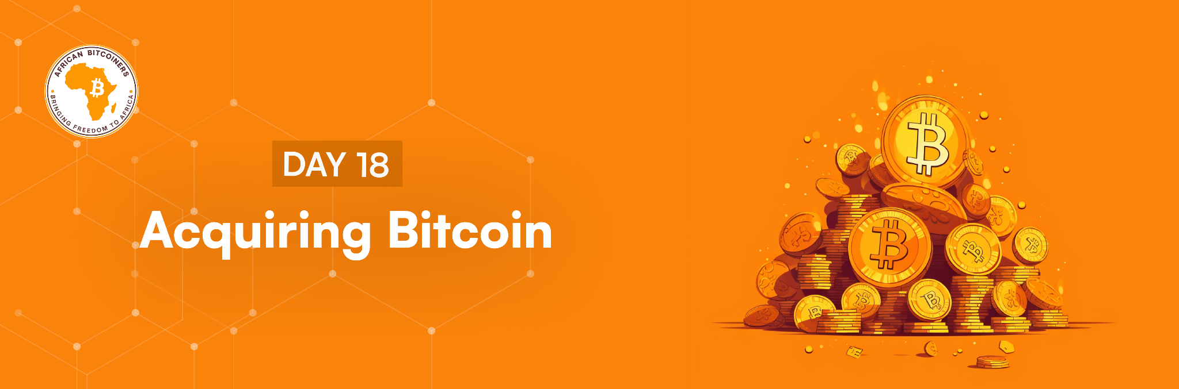

**What’s up %FIRSTNAME%?**

Now that you have an impressive knowledge of Bitcoin, let’s talk about how you can stack Bitcoin. The typical strategy for people new to Bitcoin is to first acquire a small amount of Bitcoin (sats) while learning more about it, then later, when they are a bit more knowledgeable, they could purchase more.  
  
But before we kick off with today's lesson, it's important to reiterate our commitment to helping one billion Africans hold at least one million sats each for their future. This is a significant moment for you to commit to acquiring and saving for your future, and we are here to support you every step of the way with the [Million Sat Savings Challenge](https://bitcoiners.africa/million-sat-challenge/).

Understanding the importance of saving in Bitcoin is paramount, and the [Million Sat Savings Challenge](https://bitcoiners.africa/million-sat-challenge/) is designed to be a great support in your savings journey. [Sign up](https://bitcoiners.africa/million-sat-challenge-confirmation/) to kickstart your journey.

That being said let's get into the day's lesson! Today we will be exploring and comparing the main methods of acquiring bitcoin: purchasing, earning, and mining.

**1. Direct purchase**

For most people, simply purchasing Bitcoin is likely to be the easiest and most cost-effective way to acquire it. Typically, this will involve a process of:

* Signing up with a Bitcoin exchange, Peer to Peer sites, Bitcoin buying service, or OTC (over-the-counter) desk.
* Verifying your identity (usually driver's license or passport). Note: to protect your privacy, we advice you purchase Bitcoin from P2P platforms that [do not require KYC verification please](https://kycnot.me/).
* Depositing fiat funds (like naira, cedis, rands etc.) via wire transfer or otherwise.
* Purchasing Bitcoin.
* Ideally, withdrawing the bitcoin to your custody.

Look for a reputable Bitcoin exchange or Bitcoin purchase service that has a good reputation for security and service built up over a long time.

We’ve mentioned the saying **“Not your keys, not your coins”** before and it is good advice for selecting an exchange or service that permits you to purchase and withdraw the Bitcoin to private keys under your control. There are some services that simply provide "Bitcoin exposure" without any underlying control. For users wishing to purchase Bitcoin more privately, you may find it safer to buy Bitcoin using the Peer 2 Peer method(P2P).  
  
P2P is a safer and more private way to purchase Bitcoin compared to KYC services that requires ID card verification, face verification, document verification such as utility bills as proof of address, and biometric verification before you can purchase Bitcoin. Using KYC services to buy Bitcoin means your Bitcoin can be traced back to you. You can use the P2P method to purchase Bitcoin at a local Bitcoin meetup. Many cities around the world offer these meetup groups. Following your country’s top Bitcoiners on social media is the best way to find out about meetups. And, of course, you can follow us on social media for more information too; Twitter: [@AfricanBitcoiners](https://twitter.com/afribitcoiners). For more information about buying Bitcoin peer to peer, [check out our guide.](https://bitcoiners.africa/buying-bitcoin-peer-to-peer/)

**2. Earning**

Another way to acquire Bitcoin is by working in a job that pays in bitcoin. Selling products and services for Bitcoin using "sats-back" (similar to cash-back) services such as [Lolli](https://www.lolli.com/) or [Fold](https://foldapp.com/) that give you discounts or "Bitcoin back" for purchasing through their links or services. One benefit of earning Bitcoin is that, if done correctly, it can be more private than buying Bitcoin. Those looking for merchant processing for their online stores can look to Bitcoin merchant processing companies. For a more self-sovereign method, you can use free and open-source tools like [BTCPay Server](https://btcpayserver.org/) that let you run your own web store to receive bitcoin and generate "payment requests" to automatically request the correct amount of bitcoin at current exchange rates.

**3. Mining**

Mining is another way to earn Bitcoin and is arguably the most private way to acquire Bitcoin. There have historically been many mining-based scams that promise fantastic returns or hardware that is "too good to be true". Remain skeptical of anyone who promises very high mining returns. The proper way to mine Bitcoin is by setting up your own mining hardware.

[Click here to take today's quiz](https://bitcoiners.africa/day-18-quiz/)



Another cool place to earn free sats is [**Zebedee**](https://help.zebedee.io/hc/en-us/articles/4421286397847-How-do-I-get-sats-to-start-playing-), where you earn sats for playing games.

Still holding our sats,

**African Bitcoiners**

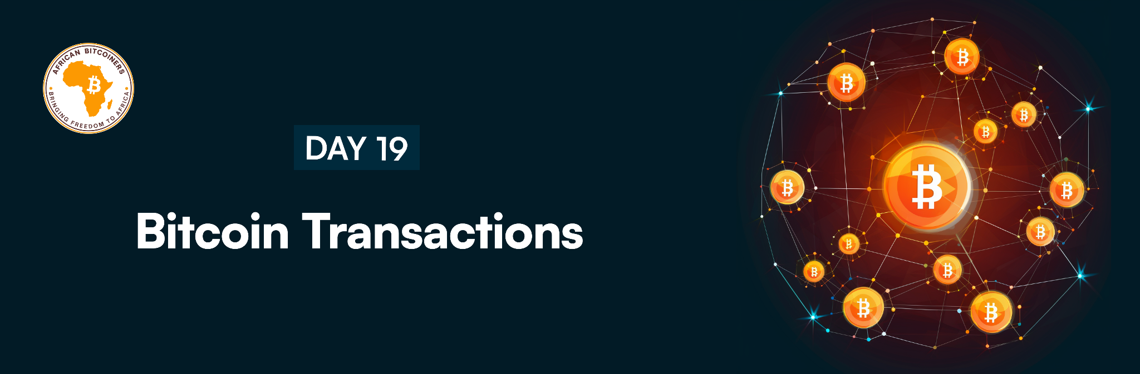

**Bonjour %FIRSTNAME%**

Today, we are talking about transactions. Transactions are the most important part of the Bitcoin Network. The entire Bitcoin system is designed to ensure that transactions can be created, sent on the network, validated, and finally added to the global ledger of transactions (the blockchain). A Bitcoin script refers to a simple programming language used to define the conditions under which a transaction output can be spent. It's a set of instructions embedded within a transaction that dictates the rules or conditions necessary to spend the funds associated with that transaction output. We are going to go over exactly what happens to a Bitcoin from the moment you hit the “send” button in your wallet until it’s received on the other end.

The path from send to receive has 3 parts:

1. Signing

2. Broadcasting

3. Confirming

**1. Signing**

Assuming Sally wanted to send Bitcoin to Bob, when Sally hits the “send” button in her wallet, what Sally is doing is telling her wallet, “Hey wallet, I want to send 1 Bitcoin to my friend Bob. Here is Bob’s Bitcoin address.”

The wallet in response evaluates Sally's UTXO (Unspent Transaction Output), which represents the Bitcoin she has available to spend. It then creates a transaction message containing information about Sally, Bob, and the amount being sent. Afterward, the wallet produces a unique digital signature for this message by mathematically mixing it with Sally's private key. Remember that Sally's private key is basically a long string of letters and numbers that act as the 'password' for her Bitcoin. Whoever knows Sally's private key has control of her Bitcoin.

A digital signature is a way to prove that you own the private key to your Bitcoin and this is mathematically encrypted into your transaction so that by using only your public key (which you will have no issue exposing), your private key is kept private.

Also, digital signatures are different each time you sign a transaction, and this is why they are even more secure than a real signature as they are unique for each and every transaction. So if Sally sends Bob Bitcoin today and then some more tomorrow, each of these transactions will have a different digital signature. After signing the transaction message, the wallet then groups the signature, along with Sally's transaction message, into a small file.

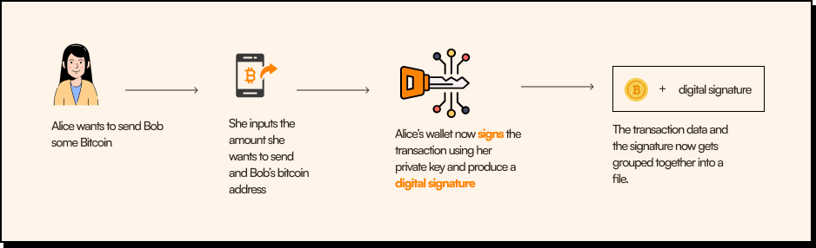

Image description of transaction signing.

**2. Broadcasting**

In this step, the wallet starts sending out the file to other computers that hold a copy of the blockchain. These computers are also known as nodes. Each node that receives the file verifies that it’s legit. It’s basically looking to see that Sally has the funds she wants to spend and that her signature checks out, much like a banker would check your account balance before clearing your check.

Once Sally's file is verified, it is then passed on to other nodes in the network that repeat this process. When a node receives a file, it keeps it in a holding area called the [Mempool](https://mempool.space/). Once the transaction message finds its way to the [Mempool](https://mempool.space/) of the different online nodes on the network, we can say the second step of broadcasting is officially finished.

Let’s pause quickly and talk about the status of Sally's transaction at this point. For Sally to actually see what’s going on with her transaction, while it’s making its path along the Bitcoin network, she can use a block explorer. A [block explorer](https://www.blockchain.com/explorer) is a tool, usually in the form of a website, that allows you to search and navigate through the blockchain. Using a block explorer, you can check the balance of different Bitcoin addresses, track transactions, and get a wide variety of statistics about the network.

So, at this point, if Sally looks at her transaction through the block explorer, she will see that it is marked as “unconfirmed”, meaning that it was broadcasted to the network and had its digital signature verified but it hasn’t been added to a block.

This type of transaction is also sometimes referred to as a zero-confirmation transaction. An unconfirmed transaction should be treated as its name implies – unconfirmed. This means that the transaction can be replaced.  
  
If your business sells or ships goods and you accept payment in bitcoin, you should never accept an unconfirmed transaction as a proof of payment.

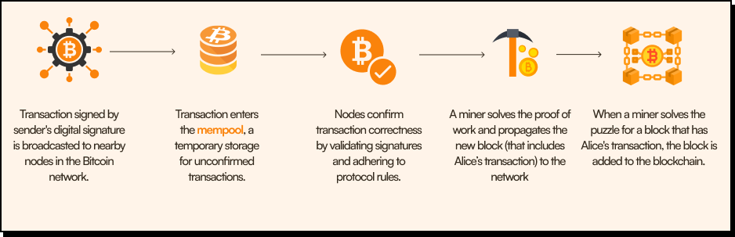

Image description of what happens when a Bitcoin transaction gets broadcasted.

**3. Confirming our transaction**

On average, a new block of transactions will be mined, or inserted into the blockchain, every 10 minutes. Keep in mind that this is on average. Sometimes you’ll get 2 blocks confirmed within 1 minute and sometimes it can take more than an hour. If a block was mined with your transaction in it, you’ll notice it will now show on the block explorer, as having one confirmation.

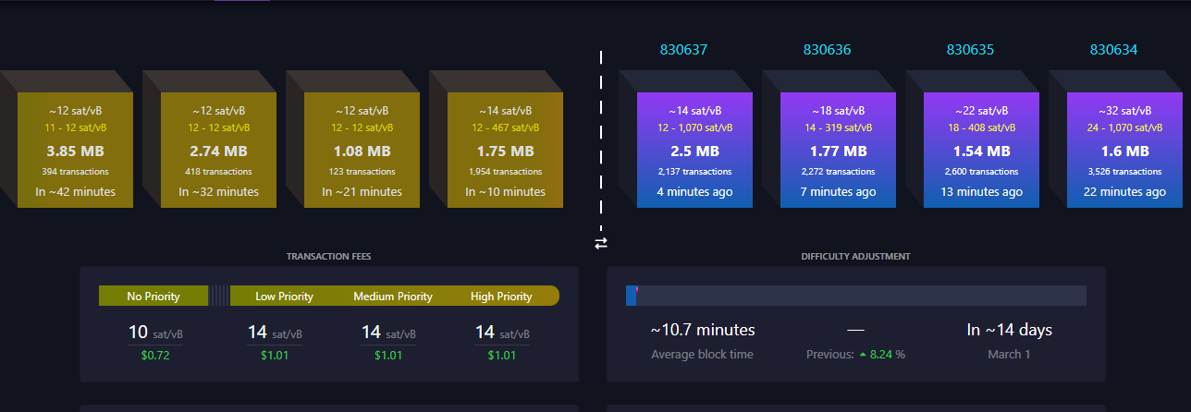

Image showing unconfirmed and confirmed transactions.

As more and more blocks are added afterward, the confirmation number will grow. Think of it as a building of blocks with our block at the very bottom. Every additional block set on top of our own block makes removing our block harder. That’s why it’s usually suggested to wait for at least 6 blocks before considering a transaction as fully confirmed without any chance of cancellation. Our transaction is now fully confirmed and received.

[Click here to take today's quiz](https://bitcoiners.africa/day-19-quiz/)



Another interesting place you can get sats reward for completing micro tasks, is on [**Microlancer**](https://microlancer.io/).

See you tomorrow!

**African Bitcoiners**

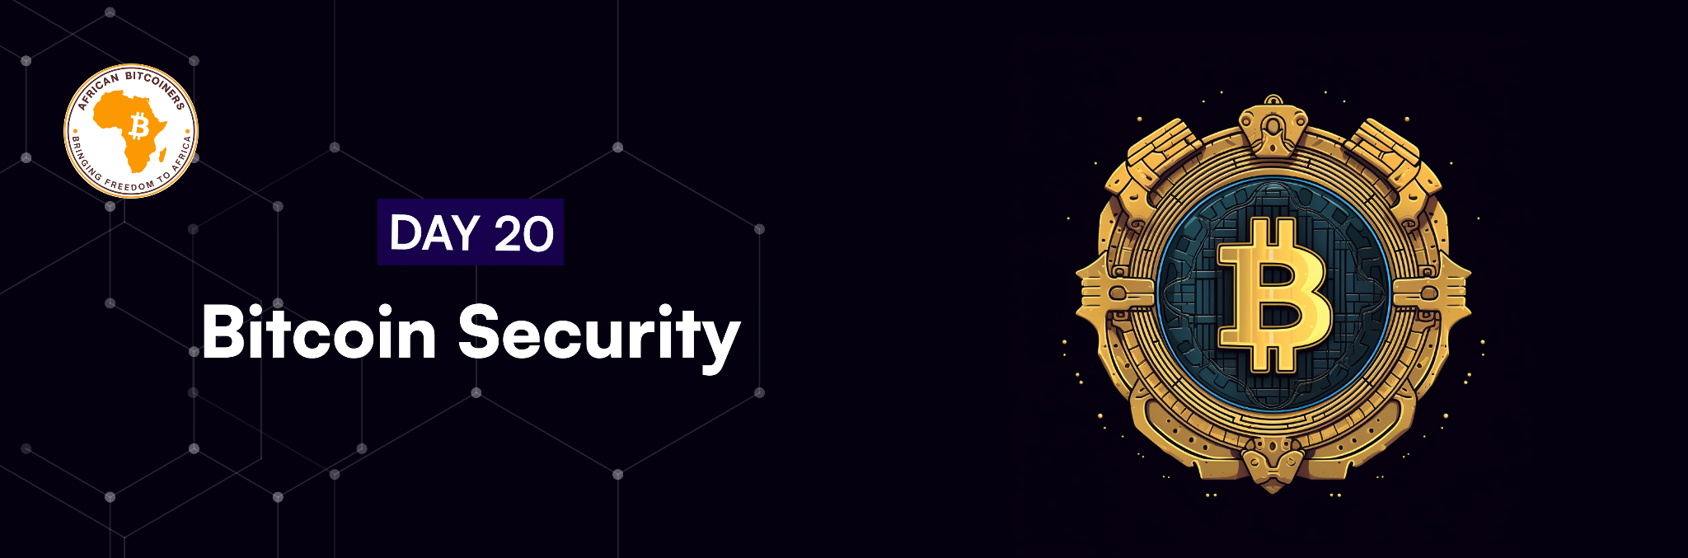

**Ya Hello-o %FIRSTNAME%**

Bitcoin security is paramount in safeguarding against a range of potential threats and attacks that can compromise its decentralized nature and users' assets. Several attacks pose significant risks to the Bitcoin network:

* **51% Attack**: As discussed this happens when a single entity or group controls over 50% of the network's mining power, potentially allowing them to manipulate transactions and undermine the network's integrity.
* **Dusting Attack:** This Involves sending small amounts of sats (dust) to wallets, compromising privacy or tracking transactions, potentially linking multiple addresses to a single entity.
* **Transaction Malleability:** This happens when transaction IDs is altered to deceive users or platforms, creating confusion about the status of transactions.
* **Phishing:** A situation where scammers attempt to acquire sensitive information, often through fake websites or emails, posing as legitimate entities to gain access to users' private keys or credentials.
* **Address Poisoning:** This involves manipulating addresses to deceive users into sending funds to unintended recipients, exploiting human error or lack of vigilance.
* **Ransomware:** A situation where a malicious software encrypts data, demanding payment in Bitcoin for decryption, affecting individuals and organizations.
* **Sybil Attack:** Involves creating multiple fake identities to control a significant portion of the network, influencing operations like denial of service, spamming, or undermining consensus.
* **Replay Attack:** A replay attack involves maliciously reusing or replaying data that was previously valid for an entirely different transaction or action.
* **Side Channel Attacks:** These exploit unintended information leakage from a system. For cryptocurrencies, these attacks focus on extracting sensitive information, such as encryption keys or transaction details, by analyzing factors like power consumption or electromagnetic emissions.
* **Routing Attacks:** These exploit vulnerabilities in the network's routing infrastructure, aiming to manipulate traffic routing.This attacks could involve redirecting or intercepting transactions, potentially leading to double-spending or denial of service
* **Eclipse Attack:** Focuses on isolating a node by providing it with false information about the network, leading it to make incorrect decisions or accept invalid data.
* **Timejacking Attack:** Attempts to manipulate a node's system clock to disrupt the block creation process and modify transactions.
* **Finney Attack:** Involves a miner with a significant amount of computational power secretly mining a block and broadcasting it once a transaction is made, attempting to double-spend.
* **Race Attack:** When an attacker attempts to spend the same coins in two different transactions at roughly the same time, exploiting the delay in confirmation to make a double-spend

Understanding these threats is critical in fortifying your Bitcoin's security and helps you enforce measures like using reputable wallets. It is important to ensure the safety of the Bitcoin in your wallet to prevent scams, theft, and loss of coins. There are many ways you can lose your Bitcoin including:

* Losing the recovery seed
* Leaving funds on exchanges or custodial wallets
* Getting tricked by sats doubling sites
* Getting scammed
* Leaving your wallet accessible with no password
* Forgetting your passphrase

Just like how we keep our cash or cards in a physical wallet, Bitcoin is also stored in a wallet, a digital wallet.

As we have learnt, the digital wallet can be hardware-based or web-based. The wallet can also reside on a mobile device, on a computer desktop, or be kept safe by printing the private keys and addresses used for access on paper.

**But how safe are any of these digital wallets?**

The answer to this depends on how the user manages the wallet. Every wallet contains a set of private keys without which the Bitcoin owner cannot access the currency. The biggest danger in Bitcoin security is the individual user perhaps losing the private key or having the private key stolen. Without the private key, the user will never see their Bitcoin again.

Besides losing the private key, a user can also lose their Bitcoin by computer malfunctions (crashing a hard drive), by hacking, or by physically losing a computer where the digital wallet resides.

There are many ways also to ensure your Bitcoin can never be lost:

**Hot wallet:**

Online wallets are also known as “hot” wallets. Hot wallets are wallets that run on internet-connected devices like computers, phones, or tablets. The issue with “Hot” wallets is that they create vulnerability because these wallets generate the private keys to your coins on these internet-connected devices. While a hot wallet can be very convenient in the way that you are able to access and make transactions with your assets quickly, they also may lack top notch security.

People who are not taking security seriously enough when using these hot wallets can have their funds stolen and this can occur in many ways. Hot wallets are meant to be used for small amounts of Bitcoin.

Any financial coach will always advise anyone to hold only spending money in a checking account while the bulk of your money is in savings accounts or other investment accounts. The same could be said for hot wallets. Hot wallets encompass mobile, desktop, web, and most exchange custody wallets.

**It is important to note that holding Bitcoin in an exchange wallet is not the same as holding it in your personal wallet.**

Exchange wallets are custodial accounts provided by an exchange e.g. Binance. The user of this type of wallet is not the holder of the private key to the coins held in this wallet. If an event were to occur where the exchange is hacked or the user’s account becomes compromised, the funds in the account would be lost. Bitcoin exchanges do not provide insurance, making safe storage of Bitcoin especially important!

As we said, it is not advisable to keep large amounts of Bitcoin in any hot wallet, especially an exchange account. While these wallets are connected to the internet, creating a potential vector of attack, they are still very useful for the ability to quickly make transactions.

It is suggested that you withdraw the majority of your funds to a "cold" wallet.

**Cold wallet**

This wallet is the safest option for Bitcoin storage as a cold wallet is a wallet that is not connected to the internet and therefore stands less chance of being compromised.

The cold wallet stores a user’s address and private key on something that is not connected to the internet and typically comes with software that works in parallel so that the user can view their portfolio without putting their private key at risk.

Cold wallets are the most secure way to store your Bitcoin, however, they require a bit more knowledge to set up. It’s essential for anyone interested in owning Bitcoin to learn about safe storage and the concepts of both hot and cold wallets. While cold wallets such as hardware wallets (e.g., [Trezor](https://trezor.io/) or [Bitkey](https://bitkey.world/en-US)) offer enhanced security, it is important to acknowledge that hardware wallets might be less accessible due to their cost.  
  
We highly recommend [Sparrow wallet](https://sparrowwallet.com/), which is a desktop wallet that allows you to set up a hot, cold, or multi-signature wallet. Check out how to set up a Sparrow wallet and as a bonus, it is built in Africa! S[et up a Sparrow wallet](https://youtu.be/qJ_SpQX_YKw). Another recommendation will be [Blue wallet](https://bluewallet.io/). These wallets prioritize user-friendly interfaces without compromising on security, making them the safest bet for those seeking an affordable yet robust cold wallet option.

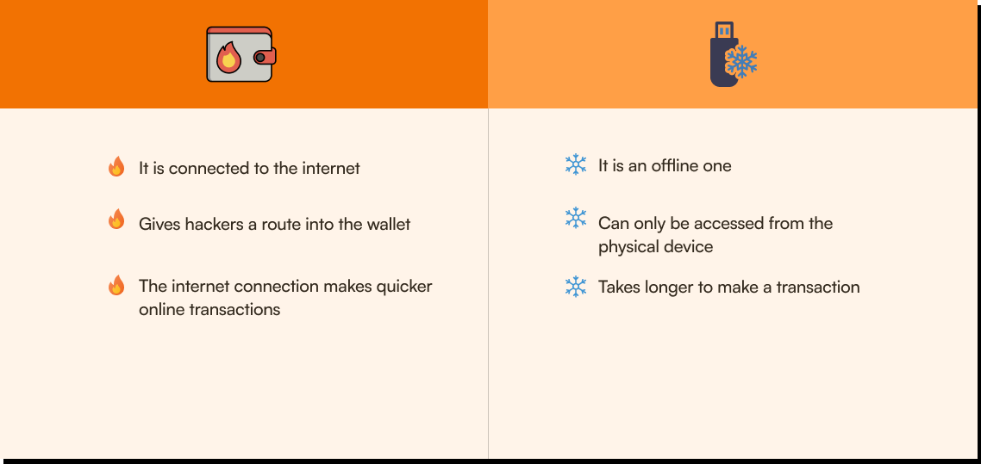

The difference between hot and cold wallet.

**Physical coins**

Services are cropping up which allow Bitcoin investors to buy physical Bitcoin. The coin you purchase will have a tamper-proof sticker covering a predetermined amount of Bitcoin. To purchase the physical coin, you may need to pay a slight premium over the value of the bitcoin that you're buying, owing to the cost of the manufacture and shipment of the coin itself.

**Security and Privacy Best Practices**

Bitcoin's transparent ledger might surprise you—it's not as private as many assume. Transactions are visible to everyone, posing a challenge to privacy. However, there are techniques available to improve anonymity and security within the blockchain.

* **Bitcoin Mixers or Tumblers:** These services improve privacy and anonymity by blending bitcoins from multiple users. By mixing transactions, it becomes challenging to trace the transaction history, significantly enhancing user privacy.
* **CoinJoin:** Similar to mixers, CoinJoin combines multiple Bitcoin payments, making it hard to link sender and receiver.
* **Timelock Transactions:** These transactions include time-based conditions, often utilized in smart contracts or for delayed fund releases, adding an extra layer of security and control.
* **Sweep Transactions**: When performing a sweep transaction, all Bitcoin associated with the private key are moved to a new address, often for the sake of convenience or security. It's particularly useful when you want to combine funds from multiple addresses or when you're transitioning to a new wallet for better management or enhanced security measures.

These techniques can significantly improve your privacy and security within the blockchain, ensuring your transactions remain confidential and protected.

Other security precautions

* Backup your entire Bitcoin wallet early and often. In case of a computer failure, a history of regular backups may be the only way to recover the currency in the digital wallet.
* Consider settiping up a multi-factor authentication for your wallet as an additional layer of security to prevent unauthorized users from accessing your wallet, even when the password has been stolen.
* Keep your software up to date. An outdated Bitcoin software wallet is vulnurable and can be exploited by hackers
* The concept of a multi-signature has gained some popularity. A multi-signature wallet requires multiple private keys to authorize a transaction. These private keys can be held by different people, such as individuals or organizations, and can be configured to require a specific number of signatures, such as two signatures out of three signatures to approve a transaction. This limits the threat of theft as a single controller or server cannot carry out the transactions.

Whewww lottss to take in today! But its better to be safe than sorry.😉

[Click here to take today's quiz](https://bitcoiners.africa/day-20-quiz/)



We have been recommending a lot of places you can earn sats throughout the course. Have you used any yet? If so, please ensure you are practising safety while stacking up all those sats! Once you save up your first 1 million sats, we advise that you transfer them to a cold wallet, as we recommended above.

Another cool place you can earn sats is by getting paid with Bitcoin for services you render or by getting a job that pays in Bitcoin. Such jobs can be found on African Bitcoiners [Bitcoin jobs page](https://bitcoiners.africa/bitcoiner-jobs/), [Bitcoiner Jobs](https://bitcoinerjobs.com/) or [Stacker news](https://stacker.news/~jobs).

Wow! you did it! One more day to go.😃

Keep sats safe.

**African Bitcoiners**

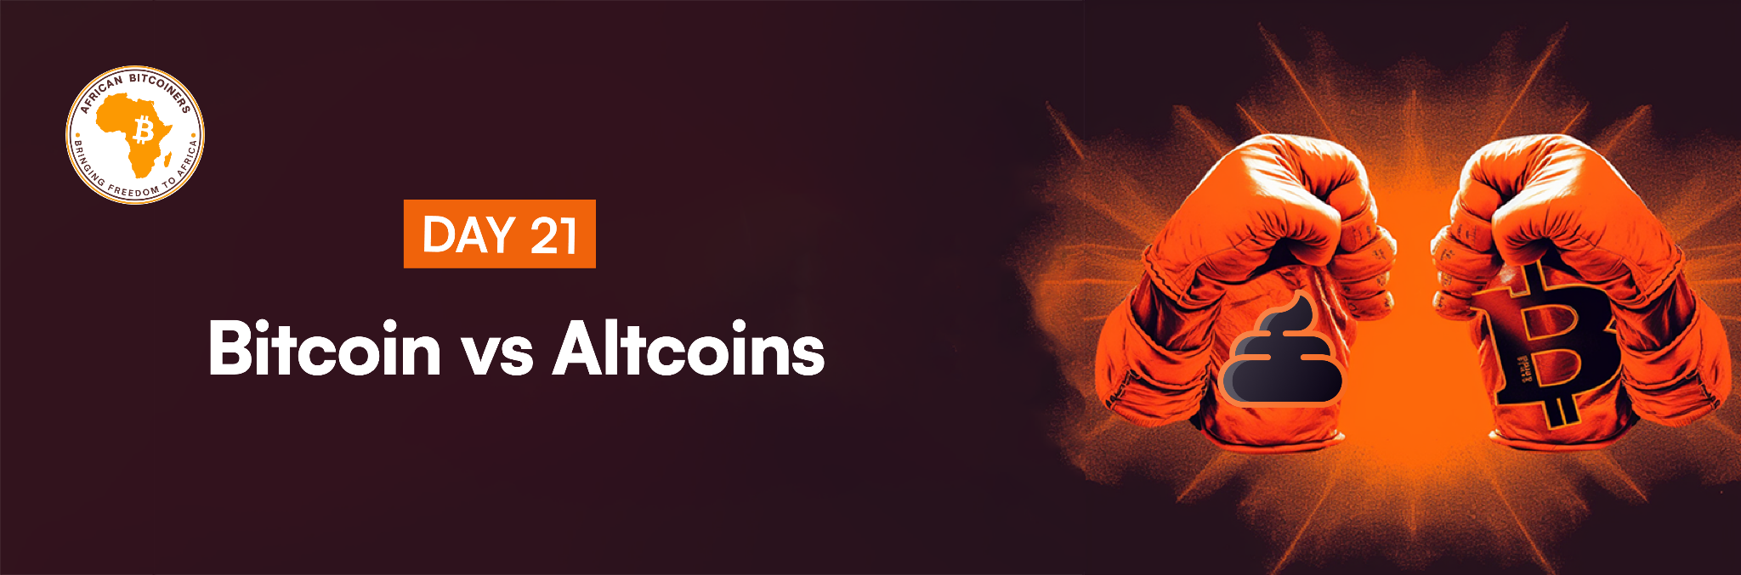

**Congratulations %FIRSTNAME%!**

**You did it, you made it to day 21!**

You may have wondered why we did all of this. We truly believe in Bitcoin and its power to transform, especially in Africa. We hope that you’re feeling as inspired to make some changes as we are.

But there is one more lesson before you start celebrating.

**So, let’s talk Altcoins**

Altcoin is short for saying “Alternative Coins”. While both Altcoins and Bitcoin use blockchain technology, these digital assets can vary in their purpose, features and operation. There are as many as 20 000 alternative cryptocurrencies, most of which are influenced by Bitcoin market price. If Bitcoin goes up, altcoins go up and if Bitcoin goes down, they all go down (although there is a difference in percentage increase or decrease). Sometimes we see exceptions of an altcoin that continue to rise when Bitcoin goes down, but the likelihood or probability of you choosing that one altcoin out of the thousands available is very low.

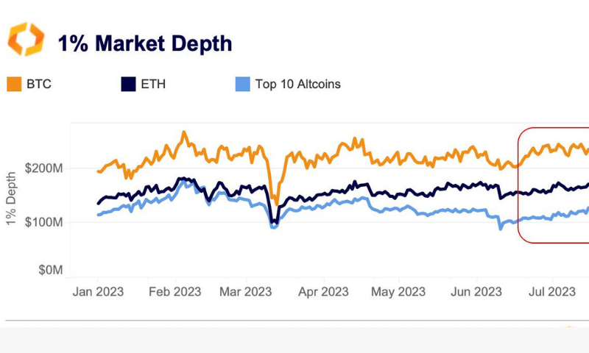

Altcoins price behavior compared to Bitcoin

Bitcoin is a societal gamechanger and a force for good, but as good as Bitcoin is, it has reawakened the irresistible desire of power-hungry individuals to control money production. History has proven that controlling money production is extraordinarily profitable for the issuer. It is now easier than ever to become a money producer and distribute it to millions of people. To this day, more than 20 000 (and counting) alternative digital currencies have been created and yet Bitcoin alone is worth more than all of them combined….

Every cryptocurrency has a person or people in the center who want to create a new money that they own the most of, except Bitcoin. Creating an alternative "cryptocurrency" today only takes a few minutes, which massively reduces the barrier of entry for money producers. These "cryptocurrency issuers" can trick individuals, businesses, and investors into believing in their worthiness. Most of these projects, if not all, are misguided or directly coordinated scams on a global scale that are causing a lot of problems. Only one class of people benefits from Altcoins in the long term: scammers.

**Let's be clear:** It's a free world, so free market participants should be allowed to build businesses on whatever they please, If fraud is out of the equation, and consistently called out. Gambling within cryptocurrency exchanges has been one of the most profitable business models around Bitcoin but it is rarely qualified with the right amount of risk disclosure to market participants. Hiding information from consumers buying products and services is the real issue.

No amount of regulatory oversight will prevent consumers from being defrauded until people understand that the market for money is unique. The market for money is one of the few markets in the world that is a winner-take-all in terms of the eventual dominant form of money. Just like we only use one internet, if one currency is better than all the others, people will gravitate to it.

This is just the start of your journey, and we are sure you are hungry for more knowledge. You can now join our Discord [community](https://discord.gg/7AycaZZR) and ask as many questions as you like. We are all here to lift each other up through Bitcoin.  
  
Before you rush to take the quiz, take a quick review of all the course content. If you feel confident that you can pass, go ahead and take the quiz below.

[Click here to take Quiz](https://bitcoiners.africa/final-quiz/)



**Are you ready for the journey of a lifetime?**

We know the end of this course may feel bittersweet,😪 but we have exciting news that will keep the momentum going!

We're committed to helping you save, starting with saving your first 1 million sats!💃🏼 Yes, you read that right. We're inviting you to [join our 1 million sats challenge](https://bitcoiners.africa/million-sat-challenge-confirmation/), where we'll provide you with all the necessary resources and support to help you stack your first million sats.

But that's not all. We want you to be part of our exclusive [Discord Community](https://discord.gg/3hpatwx8f6). This group is where you'll meet like-minded African Bitcoiners, share your experiences, and get real-time support to help you reach your goal.

Don't miss out on this opportunity to jumpstart your financial future. Join the Million Sat Challenge now and let's start stacking those sats!

Congratulations Bitcoiner!

Now stay humble and stack sats!

[Join Million Sat Challenge](https://bitcoiners.africa/million-sat-challenge-confirmation/) [Join our Discord](https://discord.gg/7AycaZZR)

Your Bitcoin evangelists,

**African Bitcoiners**